Module 1: Introduction
This module establishes the ground rules for discussions and provides students with reasoning and justification for taking this course.

Goals:
- Increase comfortability between peers
- Increase participants’ ability to discuss a variety of unfamiliar, or awkward topics with each other

Learning Objectives:
Participants will
- Understand how discussions in this course will be structured
- Become more familiar with each other

Module Summary:
 | Activity | Purpose | Materials
1 | Introduction to The Sex Talk | Gives students the opportunity to understand the purpose and importance of The Sex Talk
2 | Icebreaker | Allows students to introduce themselves to each other, communicate how they feel about the course, and become more comfortable speaking to each other | Slideshow (Handout 1.1)
3 | Discussion Guidelines | Establishes ground rules for productive and respectful discussions that are important for the rest of the course | Poster paper and writing utensils

Materials Needed:
- Handout 1.1
- Poster paper
- Markers/pens

Preparation Needed:
- If possible, arrange desks in clusters of 4 to 5.
- Prepare 1 sheet of poster paper for each cluster and 1 set of writing utensils for each cluster.
- Print out copies of Handout 1.1. Each cluster needs 1 copy.

Activity #1: Introduction to The Sex Talk
This activity helps students understand why they have to dedicate time to sex education.

Explain what The Sex Talk is.
- The Sex Talkis a sex education course consisting of 7 modules.
Explain how today is devoted to students’ understanding of The Sex Talk and why it is important to learn about sex education.
- Over the next few sessions, you will learn about the reproductive system, pregnancy, contraceptives, STIs, HIV, consent, and more.
- It is important to learn about these topics to have healthy, safe relationships.
  - At your age, many teenagers have already heard of sex and have brief conceptions of what it is. The problem is that you and your classmates do not all know the same amount. Some of you have had “the Talk”, some of you haven’t, some of you have gone further than that, and some of you have no idea what I’m talking about.
  - When everybody is stuck with this hazy concept of “S-E-X!”, it is easy to look past how there are safe and unsafe ways to engage in sexual activity.
- The Sex Talk is dedicated to providing you all with the resources and building the social skills with you to ensure you make safe and respectful choices from here on out.
  - When people become sexually active, it is important to remember that our actions might affect other people, and most importantly, they could even hurt ourselves.
Open up the floor for questions about absolutely anything. Ensure that participants know nothing is off the table.
Let students know they can contact you to talk in private about anything. Provide contact information, such as an email. Additionally, always stay after a session a couple minutes later in case a student cannot reach you online.

Activity #2: Icebreaker
This activity allows students to introduce themselves to each other, communicate how they feel about the course, and become more comfortable speaking to each other.

Instruct students to turn to the students they are clustered with and introduce themselves to each other. Allow them to talk freely for about 2 minutes.
- Introduce yourselves to each other. How old are you? What’d you eat for breakfast this morning? What’s your favorite class at school?
Pass out Handout 1.1. Tell students to talk about the questions on the sheet. They don’t need to go in order or answer them all- just whatever interests them.
Encourage disagreement and discussion. Focus on listening to new opinions.

Activity #3: Discussion Guidelines
This activity establishes ground rules for productive and respectful discussions that are important for the rest of the course.

Explain how this course relies on participants’ being able to communicate with each other and yourself.
- The Sex Talk primarily aims to disrupt the taboo surrounding sex and sexual health. One of the most productive ways to educate adolescents like yourselves is to let you all talk to each other- about how you’re feeling, about an uncomfortable topic, etc. At the end of the day, no one will be able to teach you as well as your peers because you’re all going through similar things in life right now.
Explain how ground rules are necessary to make sure everyone feels safe and comfortable talking in discussions.
- Talking to each other can be immensely productive and helpful for what we will be talking about, but only if it is done respectfully.
- We will be coming up with ground rules together that we will use for all discussions of this course.
Ask participants to tell you:
- Think about a time where you feel truly engaged and curious in a discussion. Why was that?
In groups with each other, allow participants to talk about what a “good discussion” is to them. Allow them to discuss for about 2 minutes.
Ask participants to tell you:
- What were some characteristics that were shared between members of the group?
  - *jot down those characteristics*
- Were there disagreements?
In groups with each, allow participants to make a list of characteristics of a “good discussion”. What are their ground rules? Pass out poster paper and markers. Allow discussion for about 4 minutes.
Ask groups to share their rules with the class.
Create a master list of rules- ideally a combination of rules from each group.

Module 2: The Reproductive System
This module provides the biological foundation for sex education and details on the reproductive system for the rest of the course to build on.

Goals:
- Establish an understanding of the reproductive system
- Enables students to connect the structure and function of reproductive organs
- Sets up foundation for how next modules will affect the reproductive system

Learning Objectives:
Participants can
- Locate and state the function of the primary reproductive organs in male and female systems

Module Summary:
 | Activity | Purpose | Materials
1 | Opening Discussion | Relieve awkward tension between students and encourage a more open, judgment-free environment
2 | Video | Establish reasoning for why learning about the anatomy of the reproductive systems is important | Video Link
3 | Solo Activity: Labeling | Gauges how much students already know, aims to increase awareness about lack of serious education | Handout 2.1
4 | Lecture: Male Reproductive System | Teaches students the primary internal and external organs of the male reproductive system | Handout 2.2
5 | Group Assessment | Aims to increase transparency, openness, and collaboration within groups, as well as test knowledge from the previous lecture. | Handout 2.1
6 | Lecture: Female Reproductive System | Teaches students the primary internal and external organs of the female reproductive system | Handout 2.3
7 | Group Assessment | Aims to increase transparency, openness, and collaboration within groups, as well as test knowledge from the previous lecture. | Handout 2.3
8 | Optional Solo Activity: Labeling | Gauges how much students learned from the 2 previous lectures by using the same handout from activity #3 | Handout 2.1

Materials Needed:
- Handouts
- Laptop/projector

Preparation Needed:
- Print out copies of Handouts 2.1, 2.2, and 2.3. Each student needs 1 copy of each handout.

Activity #1: Opening Discussion
This activity helps to relieve awkward tension between students and encourage a more open, judgment-free environment

Explain that Module 2 will be about the reproductive system.
- Everybody loves to joke about the reproductive system. Something about “testicles” or “ovaries” is super funny to most kids your age. So we’re going to be talking about that.
Ask clusters of students to discuss any of the following questions.
- What do you already know about the reproductive system?
- Why is it awkward to talk about anatomy? With your parents? Your siblings?
- Why do some of you know more than others?
Encourage students to talk freely. There are no inappropriate or “naughty” words.
Once allowing students to speak for about 5 minutes, ask each group to share what they discussed with the class.

Activity #2: Video
This activity helps to relieve awkward tension between students and encourage a more open, judgment-free environment

Activity #3: Labeling Worksheet
This activity helps teachers gauge how much students already know, aims to increase awareness about lack of serious education

Pass out copies of Handout 2.1.
Instruct students to work individually to complete worksheets. Unknown answers can be left blank.
Allow 10-15 minutes for completion.

Activity #4: Lecture - The Male Reproductive System
This activity teaches students the primary internal and external organs of the male reproductive system.

Explain how there was lots of confusion and uncertainty during the previous labeling activity.
- You might have found yourself questioning how much you know and being uncertain about the anatomy of the human body. Sex education is an awkward conversation to have, but an incredibly important conversation because oftentimes, you might realize just how little you know about your own body.
Introduce Activity #4.
- We will be moving into a lecture style activity for around 10 minutes. I’m going to cover the male reproductive system first, and then shortly, we’ll move into the female reproductive system.
- Do your best to pay attention; a lot of the information is and will become more important than you’d think.
  - For example, it’s difficult to know when something is off in our bodies if we don’t even know a) what is “normal”, b) where it is, or c) how to consult help to figure out what is going on.
Pass out Handout 2.2. Each student should have their own copy.
- The paper I’ve passed out is a list of the primary internal and external organs of the male reproductive system. We’re going to go over them to hopefully allow you to familiarize yourself with them.

Activity #5: Group Assessment
This activity aims to increase transparency, openness, and collaboration within groups, as well as test knowledge from the previous lecture.

Using Handout 2.1 from the labeling activity, have students in their clusters of 3 to 4 correct the male reproductive system portion of the labeling worksheet from earlier. One student will hold up their worksheet to the group, and the group will point out an incorrectly labeled organ. Anyone can correctly label the worksheet, but they must be able to list both the correct name and the correct function for the organ.

Activity #6: Lecture - The Female Reproductive System
This activity teaches students the primary internal and external organs of the female reproductive system.

Explain how you will be shortly lecturing about the female reproductive system now.
Before passing out Handout 2.3, explain the importance of the female reproductive system.
- Just like what you learned in the previous lecture about the male reproductive system, it is the same for the female reproductive system. The more you know about your own body, the higher chance you have of being able to properly take care of it.
- For the female reproductive system specifically, this system plays a big role in producing certain sex hormones, producing gametes/eggs, and more. Learning about this system is very important for the next module where we will talk about pregnancy.
Pass out Handout 2.3. Ask students to pay attention as you go over the information on the sheet.

Activity #7: Group Assessment
This activity aims to increase transparency, openness, and collaboration within groups, as well as test knowledge from the previous lecture.

Repeat Activity #5, but use the female system this time.
Using Handout 2.1 from the labeling activity, have students in their clusters of 3 to 4 correct the female reproductive system portion of the labeling worksheet from earlier. One student will hold up their worksheet to the group, and the group will point out an incorrectly labeled organ. Anyone can correctly label the worksheet, but they must be able to list both the correct name and the correct function for the organ.

Optional Activity #8: Labeling Worksheet
This activity helps teachers gauge how much students learned from the 2 previous lectures by using the same handout from activity #3.

If extra time remains in the session, pass out the same Handout 2.1 from the earlier activities and ask students to complete them on their own.
Allow students to jot down as much information as they remember on the worksheet. Additional information could include the function or common disorders of that organ. This should take around 10 minutes.
After 10 minutes have passed, ask students:
- Is there anything you learned today that was different than what you’d thought
https://www.youtube.com/watch?v=-ekRRuSa_UQ&ab_channel=FuseSchool-GlobalEducation

Module 3: Sexually Transmitted Infections
This module establishes a basic understanding of the most common STIs so that participants can act responsibly and safely.

Goals:
- Increase awareness about STIs
- Decrease taboo, embarrassment, or discomfort when talking about STIs

Learning Objectives:
Participants can
- Identify symptoms, methods of transmission, and methods of testing for the most common STIs
- Understand and reason why younger people are typically most at risk for STIs
- Understand the potential impact of contracting an STI

Module Summary:
 | Activity | Purpose | Materials
1 | Icebreaker Casual Discussion | Encourage discussion and comfortability when talking about a new module with new topics, develop an open environment between peers
2 | Misconceptions | Allow students to self reflect on their previous knowledge of STIs, identify and debunk misconceptions using factual sources
2 | Group Presentations | Increase engagement by allowing students to research and teach each other | Handout 4.1  Laptop?  Poster paper and markers
3 | What Would You Do Scenarios | Allow understanding of the impacts of STI contraction | Handout 4.2
4 | STI Knowledge Checkpoint | Increase student recollection and gauge how much students have absorbed from the module | Handout 4.3
5 | Conclusion | Emphasize importance of responsible behavior, provide resources for students | Handout 4.4, 4.5

Materials Needed:
- Handouts

Preparation Needed:
- Print out copies of Handouts 5.1, 5.2, and 5.3. You need one copy of each handout for each student.

Activity #1: Icebreaker Discussion
This activity helps encourage free flowing conversation and comfortability when talking about the new module with new topics and also helps to develop an open environment between peers.

Introduce the new module and its primary topic: sexually transmitted infections or STIs.
Ask students to turn to their groups (3-4 people per group) and discuss any of the following questions. Allow them to discuss for 5-10 minutes.
- What do you know about STIs?
- What are some misconceptions you think surround STI discussion?
- Is it awkward to talk about STIs? Why might that be?
- Do you think it is important to talk about STIs? If so, why?
Ask groups to share what they discussed or anything interesting to the class.

Activity #2: Misconceptions
This activity aims to allow students to self reflect on their previous knowledge of STIs, while identifying and debunking popular misconceptions using factual sources.

Introduce Activity #3, where the primary goal is to specifically examine what misconceptions students might have.
- Explain how misconceptions can be extremely harmful.
  - Misunderstandings about how STIs spread and their symptoms can lead to a lack of awareness about preventive measures. This increases the risk of transmission due to unawareness of safe sex practices.
  - Misconceptions often fuel stigma and shame around STIs. This stigma can prevent individuals from seeking testing, treatment, or disclosing their status, leading to further spread of infections and affecting mental health.
  - When people are misinformed about symptoms or believe they cannot contract an STI due to misconceptions, they might delay seeking medical help. Delayed treatment can lead to complications and long-term health issues.
  - Misconceptions about STIs can affect relationships. Fear of judgment or lack of understanding might hinder open communication about sexual health, potentially leading to mistrust and conflict.
  - Believing inaccurate information about STIs can give individuals a false sense of security, leading them to engage in risky behaviors without taking necessary precautions.
  - Misconceptions can contribute to the spread of STIs within communities, affecting public health initiatives aiming to prevent and control these infections.
Ask students to work in groups of 3-4.
- For 5 minutes and on their own, ask students to think about what misconceptions they might have about STIs. They do not have to be misconceptions, they can also just be uncertainties they have.
- For the next 5-10 minutes, ask students to share and discuss their thoughts in their groups. Questions to stimulate discussion include:
  - What misconceptions do you hold about STIs?
  - What misconceptions do your parents, relatives, or friends hold?
  - Are there differences in those misconceptions? Why?
  - What is your primary source for information on STIs?
  - Have you talked about SITs with your family? In previous classes?
Pass out Handout 4.4. Ask students to look over the sheet. Encourage discussion and reflection between students.

Activity #3: Group Presentations
This activity helps Increase engagement by allowing students to research and teach each other valuable information.

Introduce Activity #2 and its purpose.
- Next, we’re going to cover the most common STIs, their symptoms, how they are transmitted, possible treatments, and possible complications.
- It can be pretty boring to constantly listen to me talk and talk, so each group is going to be assigned one or two common STIs to research and present to the class. I hope that this method of peer to peer teaching will be more efficient.
- Either way, paying attention to this portion of the module is really important, as some of you discussed in the last activity. STIs can be pretty detrimental, and many are easily transmitted, so a lack of awareness or resources can end up hurting more people than you would think.
Assign groups (3-4 people per group) one or two of the most common STIs.
- Chlamydia
- Gential Herpes
- Genital Warts (HPV)
- Gonorrhea
- Hepatitis A
- Hepatitis B
- HIV/AIDS
- Scabies and Public Lice
- Syphilis
- Trichomoniasis
Pass out Handout 4.1 (one copy for each group). Depending on resources, ask students to use their laptops or phones to research their respective STIs. Students with laptops should create a shared group presentation (Canva, GoogleSlides). Students with phones should research their STI on their phone and then present the information on poster paper with pens and markers.
Allow students to research for 20-45 minutes. Encourage them not to focus on aesthetics, and really understand the content as much as possible.
Once students have finished, allow them to present their research to each other. This should take 5-10 minutes per group/per STI. Encourage students to ask each other questions.

Activity #3: What Would You Do Scenarios
This activity allows for understanding of the impacts of STI contraction.

Introduce Activity #3. Emphasize the application of what they learned in the previous activity to real world scenarios.
- Next, we will move onto Activity #3. I hope you remembered some parts of the last activity because they might be handy right now. This activity will be between partners. As the name implies, you will read hypothetical scenarios and challenge yourselves to decide what the best thing to do is in that scenario. You will use knowledge you learned about STIs to make those decisions.
- The scenarios are modeled to be very similar to what might occur in real life, so try to think realistically and responsibly. You might even find yourself in one of these scenarios one day.
Pass out Handout 4.2 (one for each partnership).
Ask students to read the handout on their own quietly for 2-3 minutes.
Once 2-3 minutes have passed, ask students to turn to their partners and discuss how they would act. Encourage students to point out differences in their responses to the scenario and discuss different actions the characters in their scenarios could take. Ask them to evaluate the pros and cons of each decision. Make sure to remind students to jot down their answers on the sheet after discussion. Allow partners to work together for 10-15 minutes or until they have completed answering all of the questions.
After 10-15 minutes have passed, go down the handout and ask the class to share how they answered each.

Activity #4: STI Knowledge Checkpoint
This activity increases student recollection and allows teachers to gauge how much students have absorbed from the module.

Introduce Activity #4. Emphasize that this activity is formatted like a test/quiz, but it will not be graded.
Pass out Handout 4.3 for students to complete individually. Allow 10-15 minutes for completion.
Once 10-15 minutes have passed, use the key to go over the answers to the handout. Ask if there are any questions or necessary clarification.

Activity #5: Conclusion
This activity emphasizes the importance of responsible behavior, provide resources for students.

Explain how this is the end of Module 3: STIs.
If time allows, ask the students what their biggest takeaway has been, what they remember most, etc.
Pass out Handouts 4.4 and 4.5. Explain the purpose of the handouts.
- The first handout, 4.4, is meant to explain and answer some questions you might have after Section B of the checkpoint handout. Misconceptions are really harmful in sex ed and conversations about sexual health, so I hope this handout can help eliminate any confusion.
- The second handout, 4.5, is meant to be an easy place to find information on common STIs. At the bottom of the page, there are a couple resources about ways to get tested for STIs.
- Let me know if anybody wants to talk to me privately after class or if anyone still has questions.

Module 4: HIV/AIDS
This module aims to help students become aware of the severity of HIV/AIDS and help to debunk commonly held, yet untrue beliefs surrounding HIV/AIDS. The module is purposely separated from Module 4 because of the historical precedence of HIV and AIDS, especially the epidemic from the early 1980s to the early 1990s.

Goals:
- Debunk the commonly held, yet untrue beliefs (especially after the AIDS epidemic)
- Decrease stigma around discussions of HIV/AIDS
- Help students become aware of the severity of the epidemic

Learning Objectives:
Participants can
- Identify the difference between AIDS and HIV
- Identify symptoms of HIV, methods of transmission, and methods of testing

Module Summary:
 | Activity | Purpose | Materials
1 | Opening Discussion | Decrease tension and encourage students to self reflect on their awareness of HIV/AIDS
2 | Micro History | Briefly establish a historical context and understanding of HIV/AIDS, establish modern implications and importance of the topic | Handout 5.1
3 | Misconceptions | Encourage self reflection, identify and debunk misconceptions | Handout 5.2
4 | Mini Lecture | Solidify information and ensure students have a factual foundation of HIV/AIDS | Handout 5.3

Materials Needed:
- Handouts

Preparation Needed:
- Print out copies of Handouts 5.1, 5.2, and 5.3. You need one copy of each handout for each student.

Activity #1: Opening Discussion
This activity decreases tension between students and encourages students to self reflect on their awareness of HIV/AIDS to aid in more productive conversations.

Introduce the new module and its primary topic: HIV and AIDS.
Ask students to turn to their groups (3-4 people per group) and discuss any of the following questions. Allow them to discuss for 5-10 minutes.
- What do you already know about HIV and/or AIDS?
- What is the difference between HIV and AIDS?
- What do you know about the AIDS epidemic?
- Why is there discomfort and uneasiness when talking about HIV or AIDS?
- Why do you think this module is separate from the Sexually Transmitted Infections module?
Ask groups to share what they discussed or anything interesting to the class.

Activity #2: Micro History of HIV/AIDS
This activity aims to briefly establish a historical context and understanding of HIV/AIDS.

Introduce Activity #3, a short but hopefully well rounded historical timeline of the HIV/AIDS crisis in the United States.
Pass out copies of Handout 5.1.
Instruct students to quickly read over the timeline on their own until they reach the horizontal line on the second page.
Once students have finished reading over the basic timeline, read out the following statistics. Emphasize how there are still modern and far reaching implications of HIV and AIDs.
Global Implications:
- There were 39 million people living with HIV in 2022, up from 31.5 million in 2010, the result of continuing new infections and people living longer with HIV. Of the people living with HIV in 2022, 37.5 million were adults and 1.5 million were children under age 15.
- HIV remains a leading cause of death worldwide and the leading cause of death globally among women of reproductive age.8 However, AIDS-related deaths have declined, due in part to antiretroviral treatment (ART) scale-up. 630,000 people died of AIDS in 2022, a 51% decrease from 1.3 million in 2010 and a 69% decrease from the peak of 2.0 million in 2004.
- Learn more: https://www.kff.org/global-health-policy/fact-sheet/the-global-hiv-aids-epidemic/#:~:text=There%20were%2039%20million%20people,were%20children%20under%20age%2015.

In the United States:
- Approximately 1.2 million people in the US have HIV. About 14 percent of them don’t know it and need testing.
- More than 700,000 people in the US have died from HIV-related illness.
- Learn more: https://www.hiv.gov/hiv-basics/overview/data-and-trends/statistics/

Emphasize how HIV and AIDS are still problems large populations of the world face today and how HIV education can work to help students stay informed and protect themselves.

Activity #3: Misconceptions
This activity aims to dismantle common misconceptions about HIV/AIDS.

Introduce Activity #3, where the primary goal is to specifically examine what misconceptions students might have.
- Explain how misconceptions can be extremely harmful, especially around the topic of HIV/AIDs.
  - Misconceptions can perpetuate stigma and discrimination against individuals living with HIV/AIDS. People who hold false beliefs about how HIV is transmitted may ostracize or isolate those who are infected, leading to social and emotional harm.
  - Misconceptions can also discourage people from getting tested for HIV or seeking treatment. Fear of judgment or misunderstanding can prevent individuals from accessing essential healthcare services. Delayed diagnosis and treatment can lead to worse health outcomes.
  - When people are misinformed about how HIV is transmitted, they may engage in risky behaviors without taking appropriate precautions. This can lead to an increased risk of HIV transmission in communities where misinformation is prevalent.
  - Individuals living with HIV/AIDS may not receive the support they need if their friends, family, or communities harbor misconceptions about the virus. Lack of support can affect mental and emotional well-being and hinder adherence to treatment.
- These are just a few reasons why dismantling misconceptions is so important.
Ask students to work in groups of 3-4.
- For 5 minutes and on their own, ask students to think about what misconceptions they might have about HIV/AIDS. They do not have to be misconceptions, they can also just be uncertainties they have.
- For the next 5-10 minutes, ask students to share and discuss their thoughts in their groups. Questions to stimulate discussion include:
  - What misconceptions do you hold about HIV/AIDs?
  - What misconceptions do your parents, relatives, or friends hold?
  - Are there differences in those misconceptions? Why?
  - What is your primary source for information on HIV or AIDs?
  - Have you talked about HIV or AIDS with your family? In previous classes?
Pass out Handout 5.2. Ask students to look over the sheet. Encourage discussion and reflection between students.

Activity #4: Mini Lecture
This activity solidifies the facts and most basic information about HIV and AIDS. It is purposefully placed at the end of the Module to encourage student curiosity and more active participation before the lecture.

Pass out Handout 5.3.
Encourage students to pay particular attention to sections about methods of HIV transmission, methods of reducing the risk of transmission, and symptoms.
Encourage students to ask questions if there is any confusion about the information provided.

Module 5: Contraceptives
This module connects the previous modules together by helping students identify ways they can prevent unintended pregnancies, STIs, and HIV/AIDS.

Goals:
- Connect Modules 3 and 4 to Module 5 to provide reasoning as to why Module 5 is important (using contraceptives to decrease chances of STIs)
- Allow to students to determine/identify as well as provide justification for effective methods of contraceptives

Learning Objectives:
Participants can
- List the most effective and least effective contraceptives at preventing pregnancy and STI transmission.
- Understand and be able to reason why the use of contraceptives is important.

Module Summary:
 | Activity | Purpose | Materials
1 | Opening Discussion | Encourages student reflection on what they already know about contraceptives and aims to break down barriers of stigma between student conversations
2 | Lecture | Establishes a foundation of factual information for students | Handout 6.1, 6.2
3 | Pros and Cons | allows students to identify what they value in a method of contraception, weigh what is most important to them, and understand the differences between various methods. | Handout 6.3
4 | Optional Mini Debate | Allows students to explore the nuances of every method and understand how different people will have different preferences, values, etc. | Handout 6.4

Materials Needed:
- Handouts

Preparation Needed:
- Print out copies of Handouts 6.1, 6.2, 6.3, and 6.4. You need one copy of each handout for each student.

Activity #1: Opening Discussion
This activity encourages student reflection on what they already know about contraceptives and aims to break down barriers of stigma between student conversations.

Introduce the new module and its primary topic: Contraceptives.
Ask students to turn to their groups (3-4 people per group) and discuss any of the following questions. Allow them to discuss for 5-10 minutes.
- What do you already know about contraceptives?
  - Where did you get your information from?
  - Have you talked to parents, relatives, etc about it before?
  - Have you done your own research about it?
  - What is the best contraceptive to prevent pregnancy?
  - What is the worst contraceptive to prevent pregnancy?
  - What is the best method to prevent STIs?
  - What is the worst method to prevent STIs?
- Are there discrepancies between how much you and your classmates know compared to each other?
  - Why?
- Why is it important to learn about contraceptives?
  - How does this module relate to previous modules about pregnancy, STIs, or HIV/AIDS?
- Why is this module important for everyone, not just female students?
Ask groups to share what they discussed or anything interesting to the class.
Make sure to emphasize:
- Education and open discourse about contraceptives is important to making sure everyone knows their options for different contraceptives, the risks of each, the pros and cons of each, and so much more.
- Abstinence is the only 100% effective way to prevent pregnancy or STIs.
  - However, there are safe ways to engage in sexual activity if proper contraceptives are used.
  - Contraceptives will decrease chances of STI transmission and pregnancy, but they will never be 100% effective.
    - Using 2 methods together is most effective because no method is 100% on its own.
- Condoms are the only method that provide protection against pregnancy and STIs.
- This module is important for all students because STIs, pregnancy, HIV/AIDS have the potential to affect everyone, regardless of sex. Learning about contraceptives is one of the best ways you can maintain good sexual health and stay safe.

Activity #2: Lecture
This activity establishes a foundation of factual information for students.

Pass out copies of Handout 6.1 and 6.2 for each student.
Instruct students to read over the handout. Instruct them to take notes of possible pros and cons of each contraceptive option. Allow 5-10 minutes.
Instruct students to pay extra attention to the effectiveness of each contraceptive option as well as how many options there are.
- Being aware of the multitude of options there allows the ability to pick the best option there is and what works best for each individual.

Activity #3: Pros and Cons
This activity allows students to identify what they value in a method of contraception, weigh what is most important to them, and understand the differences between various methods.

Introduce the activity. Emphasize how the activity is built to stimulate decision making and allow self reflection for what each student values most in a method of contraceptive.
Pass out copies of Handout 6.3.
Place students into groups of 2-3.
First, instruct students to fill out as much of the worksheet as they can. Allow 5-10 minutes.
- They do not need to list pros and cons for every method of contraceptive. They should choose the contraceptive they feel most curious about or are most familiar with. Whatever they are most drawn to.
Second, instruct students to discuss in their groups.
- Which methods were most commonly filled out in the group?
- Which methods did you like the most/prefer? Why?
- Which methods did you dislike the most? Why?
- What factors are most important to you when evaluating these methods?
  - Effectiveness?
  - Upkeep?
  - Price?
  - Complexity of use?
Last, allow groups to share what they discussed with the class.

Optional Activity #4: Mini Debate
This activity allows students to explore the nuances of every method and understand how different people will have different preferences, values, etc.

Pass out Handout 6.4. Instruct students to fill out the top half of the worksheet on their own. Allow 5-10 minutes.
Look at the chosen method of contraceptive for each student. Place students that have chosen the same method together. Divide groups into teams of 2. Place groups with opposing choices together. You should end with groups of 4 people consisting of 2 teams of 2 people that chose different preferred methods.
Instruct 1 team of each group to read out their arguments and reasoning for their choice. Allow 2-5 minutes. The other team should have limited interruptions.
After they have finished, instruct the other team of each group to share their arguments and reasoning for their opposing choice. Allow 2-5 minutes.
Once they have finished, allow groups to freely discuss. Allows 10-15 minutes.

Module 6: Healthy Relationships, Communication, and Decision Making
Outside of sexual and physical aspects of a relationship, there are emotional and social skills required for a respectful and healthy relationship. This module is the beginning of building the necessary social skills for a relationship.
At this point in the curriculum, teachers should allow students to spearhead discussions. The previous modules should have built up increased communication and less barriers/awkwardness between students, so discussions should feel more open to all.

Goals:
- Allow students to visualize what healthy relationships look like
- Allow students to self reflect on what they value in a relationship
- Teach students methods of effective communication
- Teach students what effective communication looks like and why it is important

Learning Objectives:
Participants can
- Differentiate healthy, unhealthy, and abusive relationships.
- Understand what traits and characteristics make up a healthy relationship, an unhealthy relationship, and an abusive relationship.
- Understand how communication affects a relationship.

Module Summary:
 | Activity | Purpose | Materials
1 | Opening Discussion | Encourages student reflection on what they already know about relationships and aims to break down barriers of stigma between student conversations. | Handout 7.1
2 | Traits and Values | Encourages students to identify what traits they value in a relationship as well as allow students to compare and contrast their differences in values, allows students to understand how different people will value different traits, actions, and behaviors more than others, highlighting the importance of understanding their own values clearly to allow for positive relationships and effective communication | Handout 7.1
3 | Lecture | Allows students to clearly see what traits are healthy and what traits are unhealthy, aiming to encourage students to be able to identify these traits in relationships and build better, healthier relationships. | Handout 7.2
4 | Scenarios | Allows students to apply their knowledge of healthy/unhealthy/abusive traits into scenarios that will be more similar to what they might experience themselves in their real world relationships | Handout 7.3

Materials Needed:
- Handouts

Preparation Needed:
- Print out copies of Handouts 7.1, 7.2, and 7.3. You need one copy of each handout for each student.

Activity #1: Opening Discussion
This activity encourages student reflection on what they already know about relationships and aims to break down barriers of stigma between student conversations.

Introduce the new module and its primary topic: Healthy Relationships.
- This module hopes to equip you all with important skills, such as conflict resolution and effective communication, which will become helpful in relationships, specifically in understanding boundaries, establishing respect and empathy, maintaining your emotional well being, and protecting yourself from unhealthy behaviors.
Contextualize the importance of this module in a SexEd curriculum.
- Talking about healthy relationships and communication is important both in the context of sexual relationships and in the context of other types of relationships like those with family, friends, and more.
- Within sexual relationships, discussions about healthy behaviors allows for safer sexual practices and decreased risks of harmful actions and behaviors.
- Outside of sexual relationships, discussions about healthy behaviors allow you to form positive relationships, learn how to also exemplify those healthy behaviors, and make better decisions for yourself.
Pass out copies of Handout 7.1.
Ask students to turn to their groups (3-4 people per group) and discuss any of the following questions. Allow them to discuss for 5-10 minutes. Students should jot down notes in the space provided on Handout 7.1.
- What is a healthy relationship to you?
- What does a healthy relationship look like? What actions or behaviors are exemplified in healthy relationships?
- How do you want to be treated by your friend? Your parents? Your teacher? A stranger? Your boss? Your significant other?
- What are your “green flags” in a relationship?
  - Green flags: positive, healthy traits your partner exhibits in your relationship
- What are your “red flags” in a relationship?
  - Red flags: obvious negative, potentially harmful traits your partner exhibits in your relationship
*If Activity #2 is taking place on another day, instructing students to keep their copy of Handout 7.1 with them and bring it to the next class.

Activity #2: Traits and Values
This activity aims to encourage students to identify what traits they value in a relationship as well as allow students to compare and contrast their differences in values. This discussion should allow students to understand how different people will value different traits, actions, and behaviors more than others, highlighting the importance of understanding their own values clearly to allow for positive relationships and effective communication.

Organize students into the same groups of 3-4 people as Activity #1.
Using students’ copies of Handout 7.1, instruct students to fill out the second portion of the worksheet individually. Allow 5-10 minutes for completion.
Once students have completed the second portion, instruct them to turn to their groups and discuss their answers. Emphasize that students should explain their choices of traits thoroughly. Encourage students to ask questions to each other, but also to refrain from judgemental questions or opinions. Allow 10-20 minutes for discussion.
Once 10-20 minutes have passed, instruct groups to present their findings in the discussion.
- Were there common traits the majority of the group valued?
  - Why are these traits common?
- Were there common traits the majority of the group viewed as potentially harmful?
  - Why are these traits common?

Activity #3: Lecture
This activity allows students to clearly see what traits are healthy and what traits are unhealthy, aiming to encourage students to be able to identify these traits in relationships and build better, healthier relationships.

Pass out copies of Handout 7.2.
Explain the following:
- Every person has different relationship needs. Some have higher needs for openness and affection than others, for example.
  - You should think about the traits you wrote down in the previous activity and how your traits probably differed from your classmates.
  - Healthy relationships are all about meeting each other’s needs and having mutual respect for each other. They support your work, your dreams, they stick up for you, and they don’t overstep your boundaries.
Read through the 2 lists of healthy and unhealthy traits. Explain the following:
- Different people demonstrate healthy traits in different ways and different people see healthy traits in different ways.
  - For example, if Alex texts Sam he’s going to be busy and can’t talk a lot - Sam might interpret this negatively because Alex does not want to talk to her. However, someone else might see this as a healthy behavior because Alex is communicating.
- Unhealthy traits can also be abusive at a certain point. Unhealthy traits in a relationship become abusive when they consistently and intentionally harm the well-being, autonomy, or safety of one or both partners.
- Students and adolescents may not be equipped with the necessary skills to develop and maintain healthy relationships, and may not know how to break up in an appropriate way when necessary. Maintaining open lines of communication may help them form healthy relationships and recognize the signs of unhealthy relationships, thus preventing the violence before it starts.
- At the bottom of the page, there are questions that you can use to assess relationships. These questions are meant to allow you to examine your relationship objectively and remove any bias or other influences.
Encourage students to ask clarifying questions.

Activity #4: Scenarios
This activity allows students to apply their knowledge of healthy/unhealthy/abusive traits into scenarios that will be more similar to what they might experience themselves in their real world relationships.

Pass out copies of Handout 7.3.
Organize students into groups of 2-4.
Instruct students to fill out the worksheet individually. Allow 15-20 minutes for completion.
Once completed, instruct students to discuss their answers with the group. They do not have to discuss every scenario; they can just discuss the scenarios they found particularly interesting/insightful. Encourage discussion of different answers and similar answers. Challenge students to explain why there might be different answers.

Module 7: Consent and Refusal Skills
This module aims to establish an understanding of consent to properly build and maintain safe, healthy relationships.

Goals:
- Understand when consent can be given and when it cannot be given
- Understand the importance of respecting boundaries within a relationship
- Establish effective methods of refusal

Learning Objectives:
Participants can
- Define consent
- Identify when consent can and cannot be given when given real world scenarios
- Refuse undesired actions and communicate feelings clearly

Module Summary:
 | Activity | Purpose | Materials
1 | Opening Discussion | Encourages student reflection on their current understanding of what consent is and what refusal skills look like
2 | Lecture | Establishes the principles and definition of consent | 8.1
3 | Scenarios | Allows students to apply the knowledge from the lecture to real world scenarios | 8.2

Materials Needed:
- Handouts 8.1, 8.2

Preparation Needed:
- Print out copies of Handouts 8.1 and 8.2. You need one copy of each handout for each student.

Activity #1: Opening Discussion
This activity encourages student reflection on their current understanding of what consent is and what refusal skills look like.

Introduce the new module and its primary topic: consent.
Organize students into groups of 3-4. Have them discuss the following questions for 5-10 minutes.
- What is consent? What does it look like in a relationship?
- Under what conditions can someone consent?
- Under what conditions is someone unable to consent?
- Why or why not is it important to learn about consent?
- Have you learned about consent before? From where?
Once 5-10 minutes of group discussion have passed, shift the discussion to a classroom wide setting. Have different groups share their findings, ask questions with each other, and in general, encourage all opinions and questions. This should take 10-20 minutes.
Formally introduce the importance of learning about consent.
- First, the idea of consent applies to non sexual settings just as much as it does to sexual relationships. The idea of asking permission and respecting boundaries is a universal concept that you should apply to all of your relationships and you probably have been since you were a kid.
  - For example when you were little, your mom may have or may not have asked you, “Can I have a hug?” In ideal parenting scenarios, the idea of consent is taught and modeled from a young age to encourage respectful boundaries.
- Consent also goes further than a simple "yes" or "no." It involves discussing communication, context, non-verbal cues, and the importance of ongoing, enthusiastic agreement throughout any sexual activity. These discussions help create a more informed and responsible approach to sexual interactions and thus, healthier relationships, less misunderstandings, mutual respect for autonomy, and reduced risk of sexual assault.

Activity #2: Lecture
This activity establishes the principles and definition of consent.

Pass out copies of Handout 8.1.
Read over the handout verbally to students.
Pause after each individual section (with a blue header), and encourage students to ask questions or discuss the information they are reading.

Activity #3: Scenarios
This activity allows students to apply the knowledge from the lecture to real world scenarios.

Organize students into groups of 3-4 students.
Pass out copies of Handout 8.2.
Instruct students to complete the worksheet individually first. Allow 5-10 minutes for completion.
Once students have completed the worksheet on their own, instruct them to group up and discuss their answers. Have them spend extra time on scenarios where they have differing answers or differing reasoning. Allow 10-20 minutes for discussion.
Once discussion has stopped, you will read over the scenarios out loud and go over them as a class.
- After the first scenario, ask how students answered the questions. Hear 2-3 student answers per question. After, ask the following discussion questions:
  - How do you think Jess feels?
  - Do you think that coercion like this indicates a mutually respectful relationship?
    - Emphasize how Jack is manipulating Jess by either forcing her into sexual activity or breaking up. The coercion and manipulation means Jess could not consent.
  - How can a person who feels pressured manage this situation?
    - Lead the discussion to talk about how students should deal with sexual coercion. In these cases, there are a couple key things to remember.
      - It is most important to set boundaries and reinforce boundaries. In this scenario, Jess should restate what exactly she is comfortable with clearly and vocally to Jack.
      - If your partner continues to refuse to acknowledge your boundaries, stay calm and confident. Reinforce and restate your boundaries. Stay firm in your refusal.
      - If the refusal persists, seek distance from your partner. If the manipulation continues, remove yourself from the situation. Leave the place, end the conversation, or seek a safe space to avoid further coercion or pressure.
  - Additional resources: https://psychcentral.com/sex/what-is-sexual-manipulation
- After the second scenario, ask how students answered the questions. Hear 2-3 student answers per question. If not touched on by students, make sure you
  - Emphasize how the scenario is not consensual because Maya voiced that she did not want to go further, yet Brodie still ignored her.
  - Emphasize how this scenario shows that it is okay to withdraw consent, and thus, your partner should respect your decision even if you might have consented earlier. It is okay to consent to some things and not others.
- After the third scenario, ask how students answered the questions. Hear 2-3 student answers per question. After, ask the following discussion questions:
  - Do you think there is a problem with a 13 year old being sexually active with a 17 year old? Why or why not?
    - Emphasize how this is a tricky question because the age of consent is different in every state. However, in California, 12 and 13 year olds cannot have sexual relations with people more than 2 years older than them.
    - Age gaps are important to respect for a couple reasons. First, there may be a power difference between the two. The older person may speak for the younger person or take a bigger role in making decisions. The younger person may find it more difficult to voice their opinion, especially when it comes to their concerns about the relationship. Second, when there’s a difference in age, the older person may have more experience and want to do things the younger person isn’t ready for. The younger person may feel pressured to have sex or do other sexual activities, which is never okay.
  - Would the outcome be different if the gender of the people was opposite?
    - No.
  - Additional resources; https://kidshelpphone.ca/get-info/age-gap-things-know-about-dating-someone-older/

Conclusion

You’ve reached the end!
Make sure to emphasize to students how the content covered in these modules might have seemed irrelevant or unnecessary, but they could very well have to apply lots of the concepts they learned in their own lives either sooner or later.

Please provide a copy of the Conclusion Resources to students.

Conclusion Resources

Helplines:
National Sexual Assault Hotline: 1-800-656-4673
- Available 24 hours

National Domestic Violence Hotline: 1-800-799-7233
- Available 24 hours

Trevor Project Lifeline: 1-800-788-7386
- The TrevorLifeline provides support to LGBTQ youths and allies in crisis or in need of a safe and judgment-free place to talk.

STI Testing:
Testing Site Locator: https://gettested.cdc.gov/

State by State Testing Info: https://www.healthline.com/health/healthy-sex/free-sti-testing#state-by-state-highlights

Misc.
Planned Parenthood: https://www.plannedparenthood.org/get-care/our-services
- Abortion services, birth control, emergency contraception pill, testing, HIV servies, primary care, etc.

Module 1 Handouts
Handout 1.1
Icebreaker Questions
- Discuss your opinions on sex education. Is it good? Is it bad? Can it really accomplish anything?
- What are the pros and cons of sex ed?
- Should sex ed be taught at your age? Is it too late? Too early?
- Should sex ed be taught in school?
- What have you already learned about (either on your own, from your parents, friends, etc)?
  - Why might some kids know more than others? How does that feel?
  - Is talking about sex or sexual health awkward if some know more than others?
- Have you had “the Talk”? - If all answer “yes”, what questions did you come out with?
  - Did you leave “the Talk” more knowledgeable?
  - Or did you leave with more question

Module 2 Handouts

Handout 2.1

Labeling Worksheet
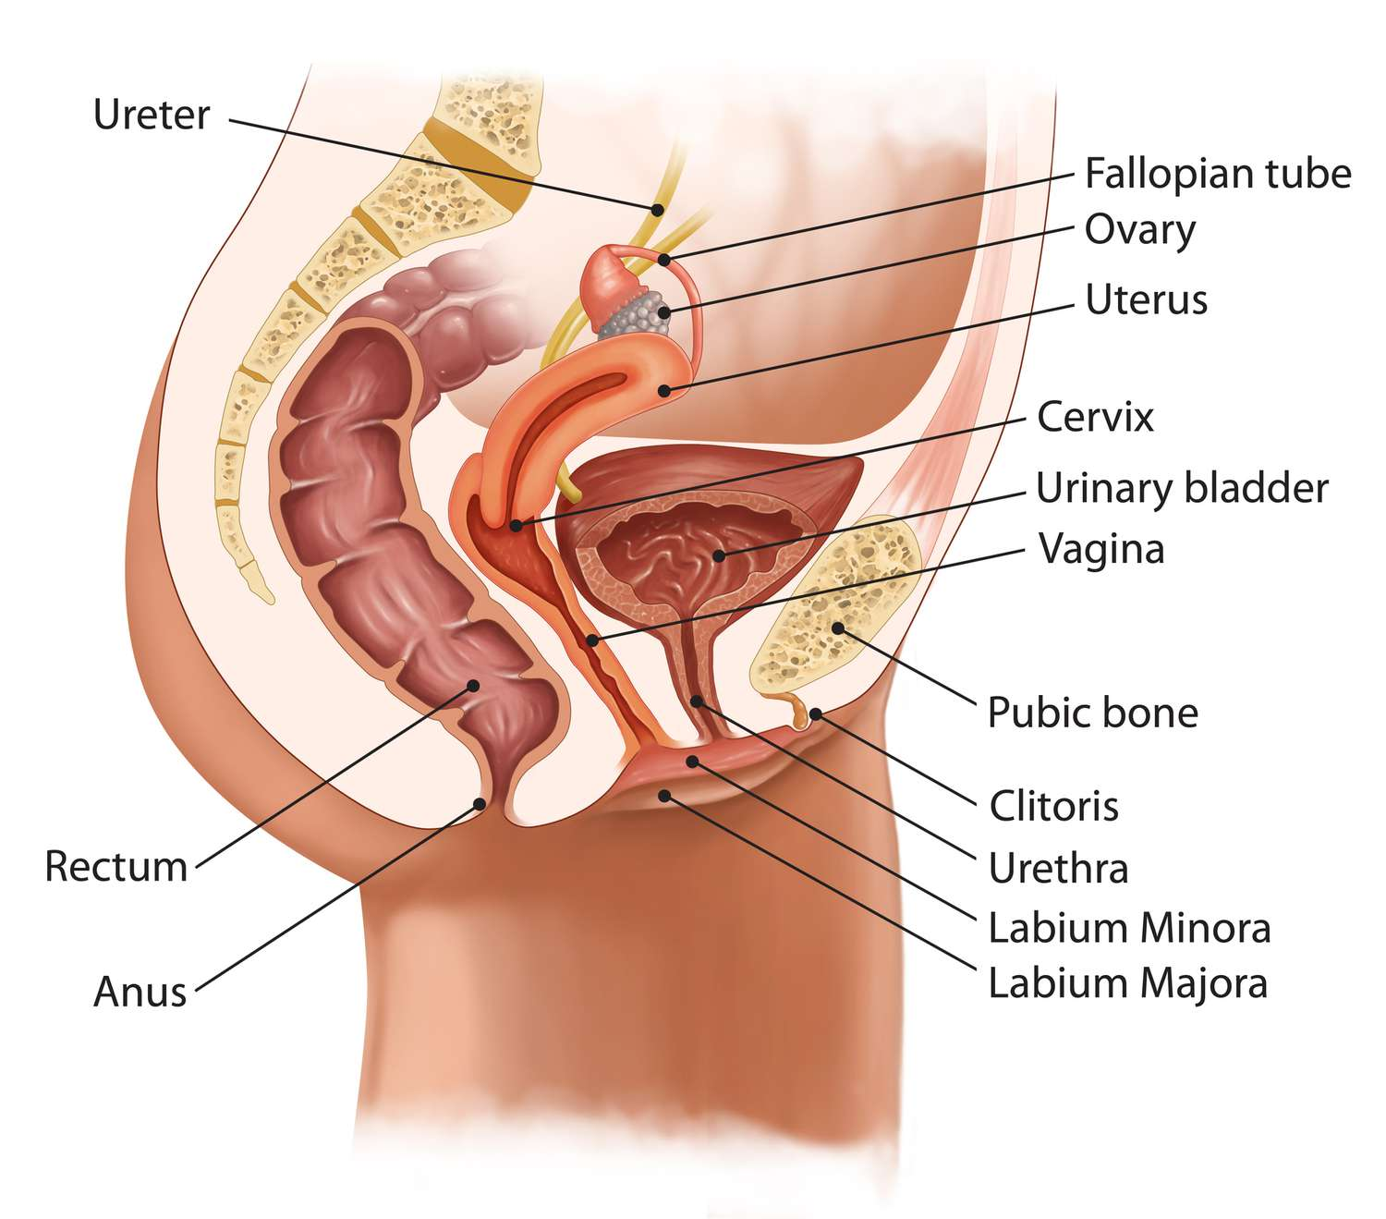

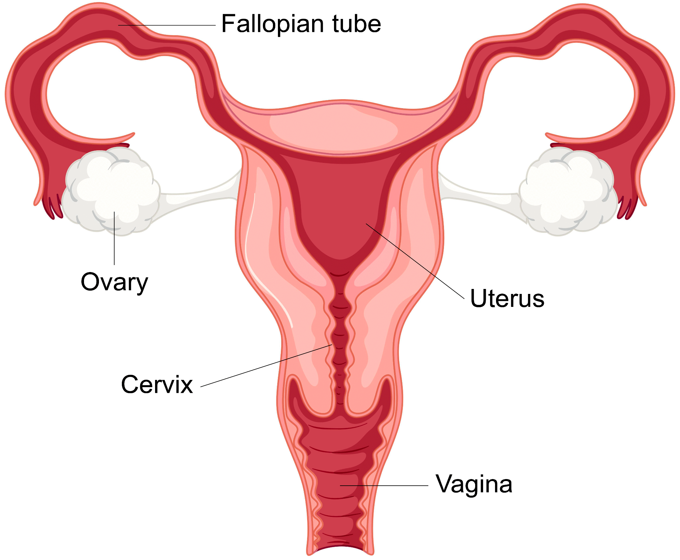

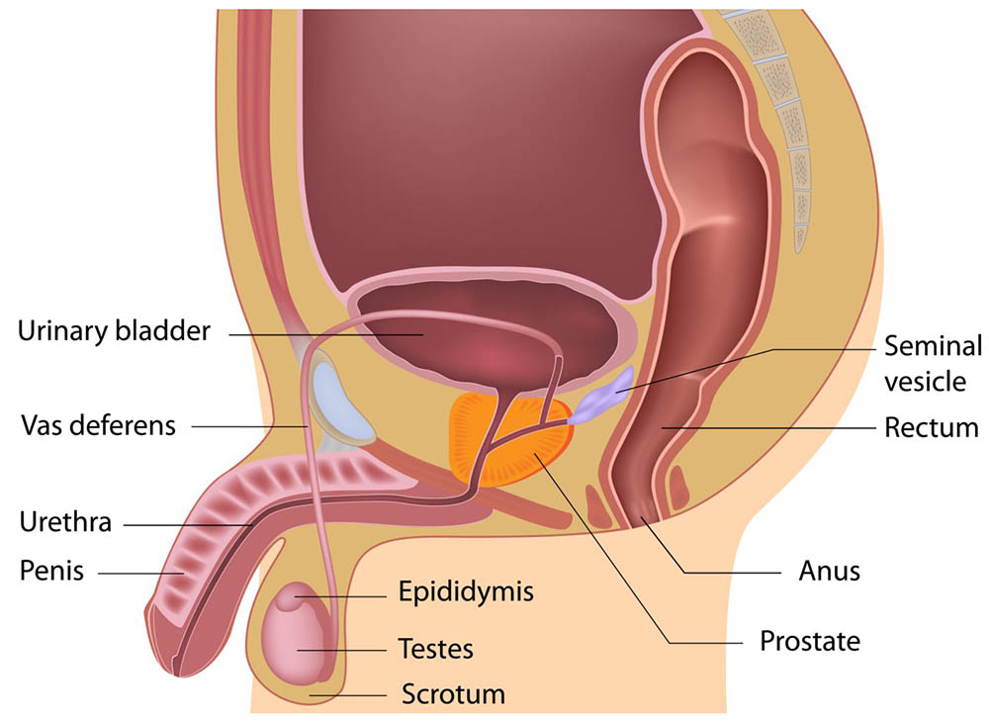

Handout 2.2

The Male Reproductive System

MALE PART | WHAT IT IS / WHAT IT DOES
PENIS  (made up of shaft, glans,  and foreskin) | Allows passage of urine and semen  Provides sensation (has many nerve endings)  The average penis measures 3–4 inches when it's not erect (flaccid)  and 5–7 inches when erect
FORESKIN | Protects the glans of the penis  Provides sensation  Males who have been circumcised don’t have one
SCROTUM | Muscular sac which is shorter when cold, longer when warm  Holds testes  Controls temperature  Provides sensation
TESTES  (also called testicles) | Produces sperm and sex hormones (androgens and testosterone)  Each is made of 500–1,200 feet of tightly coiled tubes
EPIDIDYMIS | Allows maturation of sperm
SPERMATAZOA  (sperm) | Cell from a man called sperm  Sperm carry the strings of genes (called chromosomes) or DNA instructions in case the sperm meets with an egg cell and fertilizes it
SPERMATIC CORDS | Suspends the testicles  Supply blood to the testicles  Provide sensation  Carry sperm from the testicles
VAS DEFERENS | Provides storage for sperm  Allow passage of sperm  Provides sensation  Carries sperm from the testes
SEMINAL VESICLES | Contributes fructose (sugar) to semen for nourishing the sperm
SEMEN | Helps sperm live longer and travel better  About a teaspoon per ejaculation  Contains hundreds of millions of sperm
PROSTATE GLAND | Produces most of the fluid that makes up semen
COWPER’S GLAND  (also called bulbourethral  glands) | Pair of glands  Produces pre–ejaculatory fluid (called “pre–cum”) that cleans the urethra to protect sperm. Some pre–ejaculatory fluid may contain sperm

Handout 2.3

The Female Reproductive System

FEMALE PART | WHAT IT IS / WHAT IT DOES
UTERUS  (made up of muscular  walls, a lining called  the endometrium, and  a cervix. The uterus is  also called “womb”) | Houses and protects embryo/fetus/baby  Allows nutrient & waste exchange with placenta during pregnancy  Nourishes an embryo before a placenta grows
CERVIX | The bottom section of the uterus  Produces fluids to help sperm travel  Produces a mucus plug to keep out germs during pregnancy
VAGINA | Allows passage of sperm  Produces fluid daily to cleanse and lubricate itself and help  sperm travel  Allows passage of shed endometrium during menstrual period  Allows passage of baby  Provides sensation (has many nerve endings especially in  outer third)  A collapsed tube, like a deflated balloon  Three inches long when not aroused and five to six inches long  when aroused and very stretchy  Is the middle of the three openings between a female’s legs
HYMEN | Membrane some females have that partly covers the  vaginal opening  Some girls are both without a hymen  May be stretched during use of a tampon, having finger  inserted or during sexual intercourse
OVUM  (also called “egg cell”) | Carries strings of genes called chromosomes which mix with  chromosomes of sperm if fertilization occurs  They dissolve in the Fallopian tube after about 24 hours if  not fertilized

OVARY | Provide storage for the ovum (eggs)  Allow maturation of the ovum  Produce sex hormones (estrogen, progesterone and androgens)
FALLOPIAN TUBES | Allow passage of ovum toward uterus  Allow passage of sperm from uterus
FIMBRIA | Guides a mature ovum, when it is released from an ovary, into a  Fallopian tube  Fringe–like or finger–like outer ends of the Fallopian tubes
SKENE’S GLANDS | Area of firm tissue towards the front wall of the vagina  surrounding the urethra  Responds to pressure sometimes causing orgasm that may  or may not produce fluid (the fluid is not urine)  Also known as the Graffenberg–spot (G–spot) or the female  prostate gland
VULVA  (made up of labia majora, | Protect opening of urethra and vagina, as eyelids protect eyes  Provide sensation (has many nerve endings)  Labia are folds of skin  Outer labia (labia majora) have pubic hair
labia minora, and clitoris)
CLITORIS  (made up of shaft, crura  [internal branches], glans  and hood) | Provides sensation (has many nerve endings)  Each internal branch of erectile tissue is about 3.5 inches long  The glans (the visible part) is usually .25–.5 inches long, comparable  in size to a pearl at the front of the vulva where the labia meet
CLITORIAL HOOD | Protects the glans of the clitoris  Provides sensation (has many nerve endings)  Like a cap, mostly covers the clitoris when it is not erect

Female and Male Parts
BOTH MALE AND  FEMALE | WHAT IT IS / WHAT IT DOES
NAVEL | Allows passage of oxygen and nourishment before birth  After birth it serves no purpose  Not part of the reproductive system
ABDOMEN  (also called the belly) | Contains most of our internal organs  The part of the body between the rib cage and pelvis
BUTTOCKS | Provides cushion for tail bone and aids in walking and standing  Contains muscle for movement  Not part of the reproductive system
PELVIS | Bowl–shaped bone structure that supports and protects the  internal reproductive organs  Men’s and women’s pelvises are shaped differently so that women  can give birth if they choose
CILIA | Hair–like structures which line the Fallopian tubes and the  epididymis  Sweep an ovum down the Fallopian tube or the sperm cells  through the epididymis
BLADDER | Provides storage for urine  Not part of the reproductive system
URETHRA | Allows passage of urine  In males allows passage of semen  In males is the tube inside the penis  In females it is below the clitoris and above the opening to the vagina  Not part of the reproductive system  Some females ejaculate a clear fluid that is not urine from their  urethra during orgasm. This is normal and natural and women  should not think they are urinating during orgasm if this happens.
ANUS | Allows passage of bowel movements (feces)  Provides sensation (has many nerve endings)  The opening from the rectum and lower intestines  Not part of the reproductive system

Handout 2.1 Answer KEY

Labeling Worksheet *KEY*

Module 3 Handouts

Handout 3.1

Group Presentations

Instructions: Research your STI until you can confidently answer the following questions.

If using phones for research and poster paper for presentations, jot down answers to the question on the poster paper.
If using laptops for research and digital presentations, write down answers to the questions in a digital presentation shared with your peers and your teacher.

Questions:
- What is the STI you are researching?
- What causes the STI (bacteria, parasite, virus)?
- What are common symptoms of the STI?
- How is the STI transmitted to others?
- How can someone test for the STI?
- If applicable, what are possible methods of treatment?
- What are possible complications and impacts of the STI?
- How common is the STI? In the U.S.? Globally?

Tip: Try not to focus on the aesthetics, how it looks, etc. Try to understand your assigned STI as much as possible, including misconceptions, caveats, and more. Be prepared to answer questions from the teacher and your peers.

Handout 3.2

What Would You Do?

Instructions: On your own, read the scenarios and think about how you would respond. After you have finished reading, discuss with your partner and jot down your answers.

- Austin and his partner are thinking about having sex. They decided to go to a clinic together to get tested. Once there, though, Austin’s partner backed out, saying that Austin will just have to trust that everything’s fine. What should Austin do?

- Cade and Lily have been together for a year. They’ve always used condoms. But now that Lily went on the Pill, she thinks it would be OK if they stopped using condoms. Neither one has ever been tested for STDs. She asks Cade what he thinks. How should Cade respond?

- Drew and Arianna hook up sometimes – mostly at parties when they’ve had too much to drink. Sometimes they use condoms, sometimes they don’t, and sometimes they don’t even remember. Both see other people as well. Arianna just found out she has HPV. What should Arianna do?

- Gabby just read a text message on her sister Maya’s phone from Maya’s boyfriend. He said he tested positive for herpes. Maya’s freaking out and doesn’t know what to do. How can Gabby help?

Handout 3.3

STI Knowledge Checkpoint

Section A. Write the STI under the correct description.

1. Caused by a virus that’s related to the virus that causes cold sores around the mouth. Spreads through any form of unprotected sex, and can be spread even when someone has no signs of having the virus. May not cause any symptoms or can cause repeated outbreaks of blisters and painful sores in the genital area. Has no cure, but medications can help control outbreaks.

2. Caused by certain types of the human papillomavirus (HPV). Symptoms include bumps in and around the genitals. Spreads through any sexual contact (anal, oral, and vaginal), and also by skin-to skin contact. A vaccine exists to help prevent this disease.

3. Caused by a bacterium called Neisseria gonorrhoeae. Often produces no symptoms. If there are symptoms, they may include painful urination and discharge from the penis or vagina. Can be treated with antibiotics. If left untreated, or not treated early in the infection, more serious long-term problems can result, including infertility, pain, and joint problems.

4. A common infection caused by bacteria. Spreads through any form of unprotected sex. May cause discharge, pain, and burning during urination, but often causes no symptoms at all. Can be treated with antibiotics. Untreated infections can lead to more serious health problems, such as pelvic inflammatory disease, which can lead to infertility.

5. Bacterial infection that spreads through any form of unprotected sex and by skin-to-skin contact. Typically has three stages of increasingly serious symptoms. During the early stages, can be treated with antibiotics. During the later stage, the heart, eyes, and brain may be affected. If untreated, it may increase the risk of getting HIV.

6. Transmitted through direct contact with the blood or body fluid of someone who is infected (usually through unprotected sex, sharing needles, or passed from a mother to a baby at birth). Symptoms may take 10 years or more to show. Once they appear, the person is susceptible to life-threatening infections.

Section B. True or false.
 | True | False
- I can see if my partner has an STI.
- I can’t get an STI if I only have oral/anal sex.
- If I get an STI once, I can’t get it again.
- If I use a condom, I can’t get an STI.

Handout 3.4

Misconceptions: STIs

- Myth: You can see if your partner has an STI.

Fact: Oftentimes, STIs don’t cause symptoms. People with STIs might not know they have them. They require testing, like bloodwork, for confirmation.

- Myth: STIs can be avoided by only having oral or anal sex.
Fact: Different STIs spread differently. The viruses or bacteria that cause STDs can enter the body through tiny cuts or tears in the mouth and anus, as well as the genitals. Some STDs, like herpes or genital warts, can spread just through skin-to-skin contact with an infected area or sore.

- Myth: Once you’ve had an STI, you can’t get it again.

Fact: You can get some STIs more than once. Some STDs are yours for life, like herpes and HIV. Others, like chlamydia and gonorrhea, can be treated, but you may get infected again if you have sexual contact with someone who has them.

- Myth: Only people who have multiple sexual partners get STIs.

Fact: it only takes one exposure to acquire an STI. For people who are exposed to more partners, if they're not using protection like condoms, for example, their risk of transmitting or acquiring an STI from somebody is higher than someone in a monogamous relationship.

- Myth: An STI cannot impact you significantly.

Fact: Some STIs can cause huge complications. Untreated chlamydia and gonorrhea infections can cause infertility in women. Sometimes, STIs can lead to pelvic inflammatory disease (PID), which is basically an infected fluid collection involving the fallopian tubes.

- Myth: Cold sores are an STI.

Fact: Cold sores are caused by the herpes simplex virus (HSV). HSV-1 is an oral virus that is passed with skin-to-skin contact from one person to another, such as kissing. HSV-2 is thought to cause similar lesions in the genital area. Over time, that distinction has become less important, and people can get HSV-1 or HSV-2 in both the mouth and genital area. HSV is a sexually transmitted infection that can be passed with sexual intercourse but doesn't necessarily require intercourse.

- Myth: Condoms will protect you against all STIs.

Fact: Though condoms minimize the risk of transmission of STDs, they are not 100% effective in preventing them. This is because some STDs like herpes and genital warts can spread by skin-to-skin contact. In the absence of complete coverage of an infected sore or wart by a condom, the risk of transmitting sexually transmitted infections (STIs) such as those caused by herpes simplex virus (HSV) or human papillomavirus (HPV) is increased.

- Myth: You will not get an STI if you don’t have sex.

Fact: Besides sexual contact, some STDs are spread through blood transfusions, simply kissing or touching the infected area, breastfeeding, or sharing needles with the infected. So, you can get STDs even without having sexual intercourse.

Sources: Johns Hopkins All Children’s Hospital, Phelps Health, North Atlanta Women’s Care

Handout 3.5

STI Basics Chart

INFECTION | TRANSMISSION | TYPES OF SEXUAL CONTACT THAT MAY PRESENT  A RISK OF CONTRACTING THE DISEASE | COMMON SYMPTOMS | POSSIBLE COMPLICATIONS | TREATMENT
CHLAMYDIA  (Bacteria) | Semen, pre– ejaculate (pre–cum), vaginal fluid. | Oral sex (mouth–penis, mouth–vagina)  Vaginal sex (vagina–penis)  Anal sex (anus–penis) | Often no noticeable symptoms. Potential for itching, discharge or  burning during urination or ejaculation, pain in the lower abdomen  or back, pain during intercourse, discharge from the vagina, bleeding between menstrual periods, nausea, or fever. | If left untreated, may lead to infection of the testicles or pelvic inflammatory disease  (PID) in women, a serious medical condition that can lead to infertility.  May cause infertility even without symptoms. Can be transmitted from mother to newborn during childbirth. | Curable with antibiotics.
GENITAL HERPES  (Virus) | Skin–to–skin contact (usually genital), saliva may transmit virus from the mouth  or lips.  Transmission is possible even without an outbreak of sores. | Oral sex (mouth–penis, mouth–vagina, mouth–anus)  Vaginal sex (vagina–penis)  Anal sex (anus–penis) | Often no noticeable symptoms. May cause one or more sores, blisters, pimples, bumps, or a rash around mouth, genitals or anus, itching, burning, or tingling in either the genital area or the mouth, a fever, swollen glands or stiff neck and headache. May  have repeated outbreaks that are generally less severe than the original. | May result in chronic painful condition particularly for people who have a weakened immune system. Can be transmitted from mother to newborn during childbirth. | No cure but medications can reduce the frequency and duration of outbreaks.
GENITAL WARTS (HPV)  (Human papillomavirus) | Skin–to–skin contact  (usually genital).  Transmission is possible even without visible warts. | Oral sex (mouth–penis, mouth–vagina, mouth–anus)  Vaginal sex (vagina–penis)  Anal sex (anus–penis) | Often no noticeable symptoms but may cause raised or flat growths around genitals or anus that are usually flesh colored or whitish in appearance. | Certain strains of HPV are considered risk factors for cervical cancer. In very rare cases, it can be transmitted from mother to newborn during childbirth. | No cure but warts can be removed using creams, surgery,  cryosurgery (freezing), or laser treatment.  There is now a vaccine to prevent certain types of HPV infection, including types that cause cervical cancer.
GONORRHEA  (Bacteria) | Semen, pre– ejaculate (pre– cum), vaginal fluid. | Oral sex (mouth–penis, mouth–vagina)  Vaginal sex (vagina–penis)  Anal sex (anus– penis) | May have discharge or burning during urination or ejaculation, pain in the lower abdomen  or back, pain during intercourse, discharge from the vagina, bleeding between menstrual periods, nausea, or fever. For women, there are often no noticeable symptoms. | If left untreated, may lead to infection of the testicles or pelvic inflammatory disease  (PID) in women, a serious medical condition that can lead to infertility.  Can be transmitted from mother to newborn during childbirth. | Curable with antibiotics.
HEPATITIS A  (Virus) | Feces. | Oral sex (mouth–penis, mouth–vagina, mouth–anus) | Often no noticeable symptoms but may cause fever, tiredness, aches, loss of appetite, nausea, abdominal pain, dark urine, and jaundice (yellowing of the skin and eyeballs). | In rare cases, may lead to severe liver infection and death. | Nearly all infections resolve on their own. There are vaccines to prevent hepatitis A.
HEPATITIS B  (Virus) | Blood, semen, pre-ejaculate (pre-cum), vaginal fluid. | Oral sex (mouth-penis, mouth-vagina)  Vaginal sex (vagina-penis)  Anal sex (anus-penis) | Often no noticeable symptoms but may cause mild flu-like symptoms including fever, tiredness, aches, loss of appetite, nausea, abdominal pain, dark urine, and jaundice (yellowing of the skin and eyeballs). | Can lead to chronic infection, cirrhosis (scarring of liver tissue) and cancer of the liver. Can be transmitted from mother to newborn during childbirth. | Nearly all infections resolve on their own but medications may be used to treat chronic illness. Alcohol and certain medicines should be avoided to prevent  further liver damage. There are vaccines to prevent hepatitis B.
HIV/AIDS  (Human Immuno- deficiency Virus) | Blood, semen, pre-ejaculate  (pre-cum), vaginal fluid, breast milk. | Oral sex (mouth-penis, mouth-vagina)  Vaginal sex (vagina-penis)  Anal sex (anus-penis) | Often no symptoms for years but may cause fever, chills and sweats, fatigue, appetite loss, weight loss, muscle and joint pain, long-lasting sore throat, swollen lymph nodes, diarrhea, yeast infections, and skin sores. | Over time, can lead to acquired immune deficiency syndrome  (AIDS), which can leave a body vulnerable to other infections or cancers normally controlled by a healthy immune system. Can be transmitted from mother to newborn during childbirth. | No cure or vaccine for HIV or AIDS. There are medications that allow people to live with HIV or AIDS for longer periods of time.
SCABIES & PUBIC LICE OR CRABS  (Parasite) | Skin-to-skin contact (usually prolonged sexual contact), although in rare cases, can spread by contact with clothes, towels, bedding, and other personal items that were recently in contact with an infected person | Oral sex (mouth-penis, mouth-vagina)  Vaginal sex (vagina-penis)  Anal sex (anus-penis) | Intense itching usually in genital area, visible crab eggs (small, oval-shaped, beads) attached to the base of hair, may have dark or bluish spots on skin in the infested area as a result of bites. | Scratching area may lead to secondary bacterial infections. | Medicated shampoos and creams will kill mites/lice on the body. In addition, need to thoroughly clean all clothing, towels and bedding  to prevent reinfection.
SYPHILIS  (Bacteria) | Skin-to-skin contact (between syphilis sore and penis, vagina, anus or mouth). | Oral sex (mouth-penis, mouth-vagina)  Vaginal sex (vagina-penis)  Anal sex (anus-penis) | Painless sore on or around penis, vagina, mouth or anus; rash over the entire body or on the hands and soles of the feet, fever, swollen lymph glands, patchy hair loss, headaches, weight loss, muscle aches, and tiredness. | If left untreated, may damage heart, eyes, central nervous system and other organs. Can be transmitted from mother to fetus prior to birth. | Curable with antibiotics.
TRICHOMONIASIS  (Parasite) | Semen,  pre-ejaculate  (pre-cum), vaginal fluid. | Vaginal Sex (vagina-penis, vagina-vagina) | Women may experience frothy, yellow-green vaginal discharge, discomfort during intercourse and urination, irritation  and itching in the genital area and in rare cases, lower abdominal pain. Most men do not experience symptoms but may have irritation inside the penis, mild discharge, or slight burning during urination or ejaculation. | If left untreated, on rare occasions, leads to pelvic inflammatory disease (PID) in women, a serious medical condition that can lead to infertility. | Curable with antibiotics.

Resources:
- Find the nearest clinic to get tested:
  - https://gettested.cdc.gov/
  - https://www.plannedparenthood.org/get-care/our-services
- Information about lower cost STI testing: https://www.healthline.com/health/healthy-sex/free-sti-testing#average-cost

Handout 3.3 Answer KEY

STI Knowledge Checkpoint *KEY*

Section A.
- Genital herpes
- Genital warts
- Gonorrhea
- Chlamydia
- Syphilis
- HIV/AIDS

Section B.
- F
- F
- F
- F

Module 4 Handouts

Handout 4.1
Timeline of HIV/AIDS

1981: The first recognized cases of a new illness affecting gay men are reported in the United States, initially referred to as "Gay-related Immunodeficiency" (GRID).

1983: Scientists discover the virus responsible for causing AIDS, initially called HTLV-III (Human T-cell Lymphotropic Virus-III) and later renamed HIV (Human Immunodeficiency Virus).

1984: Dr. Robert Gallo and his team at the National Cancer Institute announce the discovery of HIV as the cause of AIDS, nearly simultaneously with a French team led by Dr. Luc Montagnier.

1985: The FDA approves the first blood test to detect HIV antibodies, allowing for the screening of blood donations.

1987: The first antiretroviral drug, AZT (zidovudine), is approved for the treatment of HIV/AIDS.

1996: The introduction of highly active antiretroviral therapy (HAART) significantly improves the treatment of HIV/AIDS, leading to a decline in AIDS-related deaths.

2000: The United Nations launches the Millennium Development Goals, including a goal to combat HIV/AIDS, which leads to increased international efforts to address the epidemic.

2003: The President's Emergency Plan for AIDS Relief (PEPFAR) is established in the United States to provide funding for HIV/AIDS prevention, treatment, and care in heavily affected countries.

2011: UNAIDS announces the "Getting to Zero" campaign, with the goals of zero new HIV infections, zero discrimination, and zero AIDS-related deaths.

2012: The FDA approves the use of pre-exposure prophylaxis (PrEP) as a preventive measure for people at high risk of HIV infection.

2014: The "90-90-90" target is introduced by UNAIDS, aiming to have 90% of people living with HIV knowing their status, 90% of those diagnosed receiving antiretroviral therapy, and 90% of those on treatment having suppressed viral loads by 2020.

2020: The world grapples with the COVID-19 pandemic, which has implications for HIV testing, treatment, and prevention efforts, highlighting the importance of global health coordination.

2021: The COVID-19 pandemic continues to impact HIV/AIDS programs, but there is ongoing progress in HIV prevention, treatment, and research.

Global Implications:
- There were 39 million people living with HIV in 2022, up from 31.5 million in 2010, the result of continuing new infections and people living longer with HIV. Of the people living with HIV in 2022, 37.5 million were adults and 1.5 million were children under age 15.
- HIV remains a leading cause of death worldwide and the leading cause of death globally among women of reproductive age.8 However, AIDS-related deaths have declined, due in part to antiretroviral treatment (ART) scale-up. 630,000 people died of AIDS in 2022, a 51% decrease from 1.3 million in 2010 and a 69% decrease from the peak of 2.0 million in 2004.
- Learn more: https://www.kff.org/global-health-policy/fact-sheet/the-global-hiv-aids-epidemic/#:~:text=There%20were%2039%20million%20people,were%20children%20under%20age%2015.

In the United States:
- Approximately 1.2 million people in the US have HIV. About 14 percent of them don’t know it and need testing.
- More than 700,000 people in the US have died from HIV-related illness.
- Learn more: https://www.hiv.gov/hiv-basics/overview/data-and-trends/statistics/

Handout 4.2
Misconceptions: HIV/AIDS

- Myth: HIV is the same as AIDS.

Fact: HIV (Human Immunodeficiency Virus) is the virus that can lead to AIDS (Acquired Immunodeficiency Syndrome). HIV is the initial infection, and AIDS is a later stage of the disease when the immune system is severely damaged. Not everyone with HIV will develop AIDS, especially with access to modern antiretroviral treatment.

- Myth: HIV can be transmitted through casual contact.

Fact: HIV is primarily transmitted through unprotected sexual intercourse, sharing needles for drug use, or from mother to child during childbirth or breastfeeding. It is not transmitted through hugging, kissing, shaking hands, sharing utensils, or by being in the same room as someone with HIV.

- Myth: HIV can be transmitted through saliva or tears.

Fact: HIV is not transmitted through saliva or tears, even if someone with HIV has these fluids on their skin or mucous membranes. It is not present in sufficient quantities in these bodily fluids to transmit the virus.

- Methods of HIV transmission: https://www.cdc.gov/hiv/basics/hiv-transmission/ways-people-get-hiv.html

- Myth: You can tell if someone has HIV by looking at them.

Fact: HIV does not have visible symptoms that can be detected by looking at someone. In fact, the CDC reports one in seven people who are infected with HIV don’t even know it. The only way to know if a person has HIV is for them to get tested and share their positive results. People with HIV can appear healthy for many years, and symptoms may not be noticeable until the virus has progressed to a more advanced stage.

- Myth: Only certain groups of people are at risk for HIV.

Fact: While certain populations, such as men who have sex with men, people who inject drugs, and individuals in some high-prevalence regions, have a higher risk of HIV infection, anyone who engages in risky behaviors can contract the virus. HIV does not discriminate based on gender, sexual orientation, race, or socioeconomic status.

- Myth: There is a cure for HIV.

Fact: There is no cure for HIV. While antiretroviral therapy (ART) can effectively manage the virus and prevent its progression to AIDS, it does not eliminate the virus from the body. Researchers continue to work on finding a cure, but it remains elusive.

- Myth: HIV is a death sentence.

Fact: With proper medical care and adherence to antiretroviral treatment, many people with HIV can live long and healthy lives. Advances in treatment have significantly improved the prognosis for people living with HIV.

Sources: Neighborhood Outreach Access to Health, Cleveland Health Clinic

Handout 4.3
HIV/AIDs Fact Sheet

What is HIV?
HIV stands for human immunodeficiency virus, which is the virus that causes HIV infection. The abbreviation “HIV” can refer to the virus or to HIV infection.

What is AIDS?
AIDS stands for acquired immunodeficiency syndrome. AIDS is the most advanced stage of HIV infection.

HIV attacks and destroys the infection-fighting CD4 cells (CD4 T lymphocyte) of the immune system. The loss of CD4 cells makes it difficult for the body to fight off infections, illnesses, and certain cancers. Without treatment, HIV can gradually destroy the immune system, causing health decline and the onset of AIDS. With treatment, the immune system can recover.

How is HIV transmitted?
HIV can be transmitted from one person to another when certain bodily fluids are shared between people.
- Blood
- Semen
- Pre-seminal fluid
- Vaginal fluids
- Rectal fluids
- Breastmilk.

HIV can be transmitted
- During vaginal or anal sex
- Through sharing needles for injecting drugs or tattooing
- By getting stuck with a needle that has the blood of someone with HIV on it
- Through pregnancy
- Through breastfeeding

How can a person reduce the risk of transmitting HIV?
ART reduces the risk of HIV transmission. ART can reduce a person’s viral load to an undetectable level. An undetectable viral load means that the level of HIV in the blood is too low to be detected by a viral load test. People with HIV who maintain an undetectable viral load have no risk of transmitting HIV to their HIV-negative partner through sex.

HIV medicines taken during pregnancy, childbirth, and breastfeeding can also reduce the risk of perinatal (parent to infant) transmission of HIV.

What is the treatment for HIV?
Antiretroviral therapy (ART) is the use of HIV medicines to treat HIV infection. People on ART take a combination of HIV medicines (called an HIV treatment regimen) every day (pills) or by schedule (injections). In many cases oral medicines may be combined into a single pill or capsule. There are newer long-acting medicines given by an injection every 2 months that may be used in some people.

ART is recommended for everyone who has HIV. ART prevents HIV from multiplying, which reduces the amount of HIV in the body (called the viral load). Having less HIV in the body protects the immune system and prevents HIV infection from advancing to AIDS. ART cannot cure HIV, but HIV medicines can help people with HIV live long, healthy lives.

How can a person reduce the risk of getting HIV?
For people without HIV, there are several ways to reduce the risk of acquiring (getting) HIV infection.
- Using condoms correctly with every sexual encounter, particularly with partners that are HIV positive with a detectable viral load or with partners whose HIV status is unknown, can reduce the risk of acquiring HIV.
- Limiting and reducing sexual partners
- Avoiding sharing needles

Persons who do not have HIV should talk to their health care provider about pre-exposure prophylaxis (PrEP). PrEP is an HIV prevention option for people who do not have HIV but who are at risk of becoming infected with HIV. PrEP involves taking a specific HIV medicine every day or a long-acting injection. For more information, read the HIVinfo fact sheet on Pre-exposure Prophylaxis (PrEP).

What are the symptoms of HIV and AIDS?
Within 2 to 4 weeks after infection with HIV, some people may have flu-like symptoms, such as fever, chills, or rash. The symptoms may last for a few days to several weeks. Other possible symptoms of HIV:
- night sweats
- muscle aches
- sore throat
- Fatigue
- swollen lymph nodes
- mouth ulcers

Having these symptoms does not mean you have HIV. Other illnesses can cause the same symptoms. Some people may not feel sick during early HIV infection (called acute HIV). During this earliest stage of HIV infection, the virus multiplies rapidly. After the initial stage of infection, HIV continues to multiply but at lower levels.

More severe symptoms of HIV infection for persons not on ART may not appear for many years until HIV has developed into AIDS. People with AIDS have weakened immune systems that make them prone to opportunistic infections. Opportunistic infections are infections and infection-related cancers that occur more frequently or are more severe in people with weakened immune systems than in people with healthy immune systems.

HIV Tests for Screening and Diagnosis
HIV tests are very accurate, but no test can detect the virus immediately after infection. How soon a test can detect HIV depends on the type of test being used.

- Antibody tests look for antibodies to HIV in a person’s blood or oral fluid
  - Can take 23 to 90 days to detect HIV after exposure
  - Most rapid tests and the only FDA-approved HIV self-test are antibody tests
  - Use blood from a vein can detect HIV sooner after infection than tests done with blood from a finger stick or with oral fluid.
- Antigen/antibody tests look for both HIV antibodies and antigens. Antibodies are produced by a person’s immune system when they’re exposed to viruses like HIV. Antigens are foreign substances that cause a person’s immune system to activate. If a person has HIV, an antigen called p24 is produced before antibodies develop. Antigen/antibody tests are recommended for testing done in labs and are common in the United States.
  - Can usually detect HIV 18 to 45 days after exposure. There is also a rapid antigen/antibody test available that is done with a finger stick.
  - Antigen/antibody tests done with blood from a finger stick can take 18 to 90 days after exposure.
- NATs look for the actual virus in the blood. This test should be considered for people who have had a recent exposure or a possible exposure with early symptoms of HIV and have tested negative with an antibody or antigen/antibody test.
  - A NAT can usually detect HIV 10 to 33 days after exposure.

An initial HIV test usually will either be an antigen/antibody test or an antibody test. If the initial HIV test is a rapid or self-test and it is positive, the person should go to a health care provider to get follow-up testing. If the initial HIV test is a lab test and it is positive, the lab will usually conduct follow-up testing on the same blood sample as the initial test. Although HIV tests are generally accurate, follow-up tests allow the health care provider to confirm the result.

Source: HIVinfo.gov

Module 5 Handouts
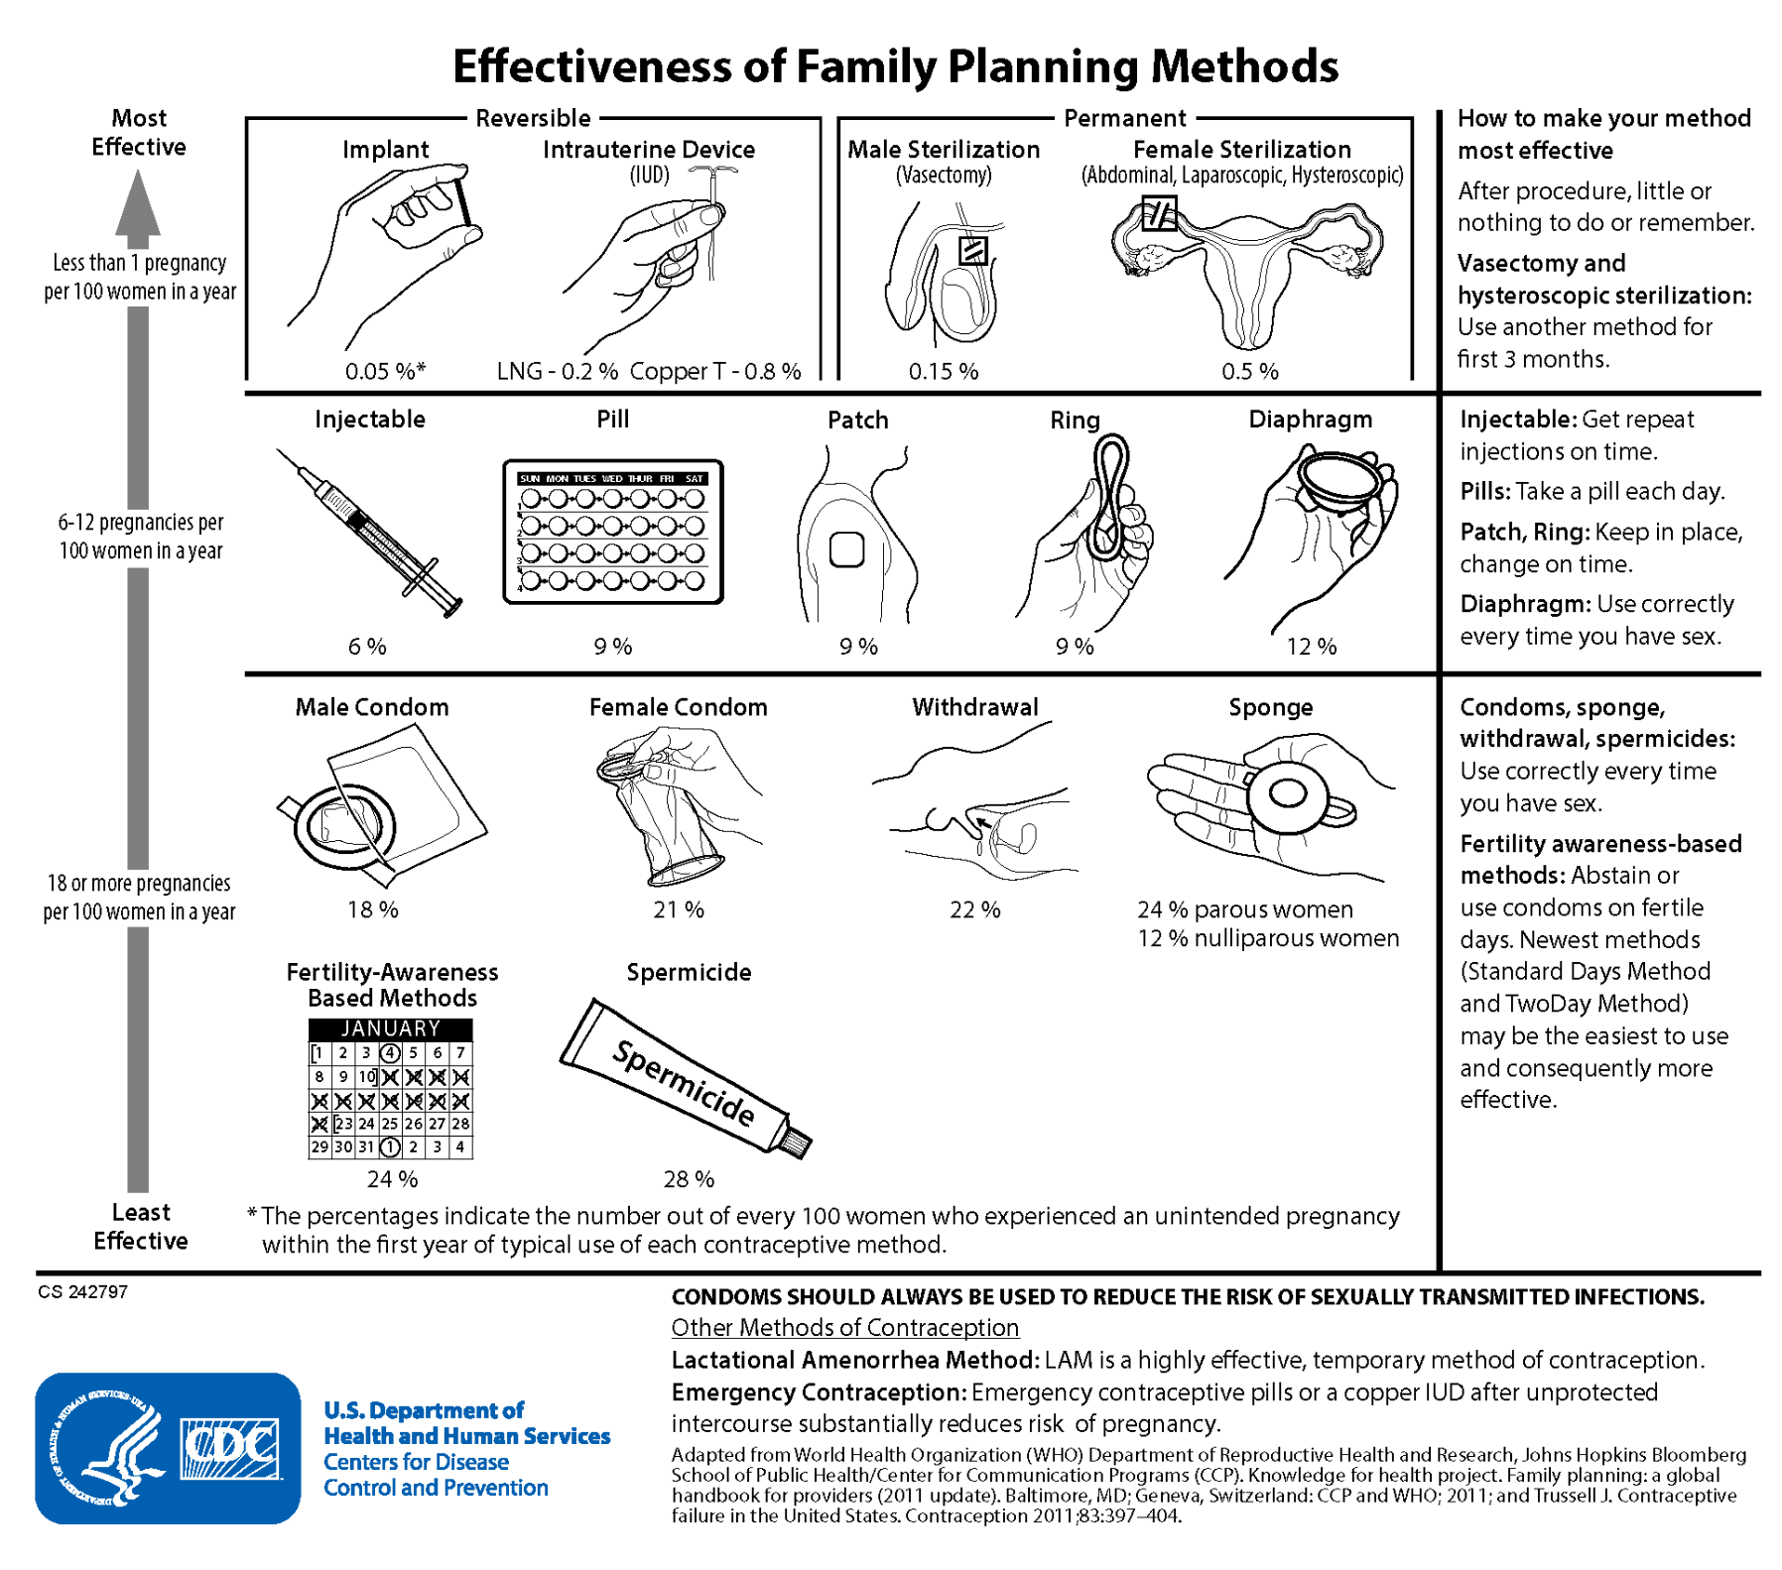
Handout 5.1

Handout 5.2
Contraceptives Fact Sheet

Method | How to Use | Impact on Menstruation | Things to Know | How well does it work?
External Condom | • Use a new condom each time you have sex  • Use a polyurethane condom if allergic to latex | None | • Can buy at many stores  • Can help prevent early ejaculation  • Can be used for oral, vaginal, and anal sex  • Protects against HIV and other STIs  • Can decrease penile sensation  • Can cause loss of erection  • Can break or slip off  • Does not need a prescription | 87%
Internal Condom | • Use a new condom each time you have sex  • Use extra lubrication as needed | None | • Can be used for anal and vaginal sex  • May increase vaginal/anal pleasure  • Good for people with latex allergy  • Protects against HIV and other STIs  • Can decrease penile sensation  • May be noisy  • May be hard to insert  • May slip out of place during sex  • May require a prescription from your healthcare provider | 79%
Diaphragm | • Put in vagina each time you have sex  • Use with spermicide every time | None | • Can last several years  • Costs very little to use  • May protect against some infections, but not HIV  • Using spermicide may raise the risk of getting HIV  • Should not be used with vaginal bleeding or infection  • Raises risk of bladder infection | 83%
Emergency Pills | • Works best the sooner you take it after unprotected sex  • You can take EC up to 5 days after unprotected sex  • If pack contains 2 pills, take both at once | • Your next period may come early or late  • May cause spotting | • Available at pharmacies, health centers, or health care providers: call ahead to see if they have it  • People of any age can get progestin EC without a prescription  • May cause stomach upset or nausea  • Progestin EC does not interact with testosterone, but we don’t know whether Ulipristal acetate EC does or not  • Ulipristal acetate EC requires a prescription • May cost a lot  • Ulipristal acetate EC works better than progestin EC if your body mass index (BMI) is over 26.  • Ulipristal acetate EC works better than progestin EC 3-5 days after sex | 58-94%
Calendar Method - Fertility Awareness | • Predict fertile days by: taking temperature daily, checking vaginal mucus for changes, and/or keeping a record of your monthly bleeding  • It works best if you use more than one of these methods  • Avoid sex or use condoms/spermicide on fertile days | • Does not work well if your period is irregular | • Costs little  • Can help with avoiding or trying to become pregnant  • Use a different method on fertile days • This method requires a lot of effort  • Does not require a prescription | 85%
The Implant | • A clinician places it under the skin of the upper arm  • It must be removed by a clinician | • Can cause irregular bleeding and spotting  • After 1 year, you may have no period at all  • Cramps often improve | • Long lasting (up to 5 years)  • You can become pregnant right after it is removed  • It may lower the risk of uterine lining cancer, ovarian cancer, and polycystic ovary syndrome (PCOS)  • May cause mood changes | >99%
Copper IUD | • Must be placed in uterus by a clinician  • Usually removed by a clinician | • May cause cramps and heavy periods  • May cause spotting between periods  (if you take testosterone, this may not be an issue) | • May be left in place for up to 12 years  • You can become pregnant right after removal  • It may lower the risk of uterine lining cancer, ovarian cancer, and polycystic ovary syndrome (PCOS)  • Rarely, uterus is injured during placement | >99%
Hormonal IUD | • Must be placed in uterus by a clinician  • Usually removed by a clinician | • May improve cramps  • May cause lighter periods, spotting, or  no period at all | • Uses levonorgestrel, a progestin  • May be left in place 3 to 8 years, depending on which IUD you choose  • You can become pregnant right after removal  • It may lower the risk of uterine lining cancer, ovarian cancer, and polycystic ovary syndrome (PCOS)  • Rarely, uterus is injured during placement | >99%
The Patch | • Apply a new patch once a week for three weeks  • No patch in week 4 | • Can make periods more regular and less painful  • May cause spotting the first few months | • You can become pregnant right after stopping patch  • Can irritate skin under the patch  • This method contains estrogen - it is unclear if estrogen interacts with testosterone | 93%
The Pill | • Take the pill daily | • Often causes spotting, which may last for many months | • Can improve PMS symptoms  • Can improve acne  • Helps prevent cancer of the ovaries  • This method contains estrogen - it is unclear if estrogen interacts with testosterone  • You can become pregnant right after stopping the pills  • May cause nausea, weight gain, headaches, change in sex drive - some of these can be relieved by changing to a new brand | 93%
The Ring | • Insert a small ring into the vagina  • Monthly Ring: Change ring each month  • Yearly Ring: Change ring each year | • Can make periods more regular and less painful  • May cause spotting the first few months  • Can increase vaginal discharge | • There are two types: a monthly ring and a yearly ring.  • One size fits all • Private  • You can become pregnant right after stopping the ring  • This method contains estrogen - it is unclear if estrogen interacts with testosterone | 93%
The Shot | • Get a shot every 3 months (13 weeks)  • Give yourself the shot or get it in a medical office | • Often decreases flow  • May cause spotting or no period | • Each shot works for up to 15 weeks  • Private for user  • Helps prevent cancer of the uterus  • May cause weight gain, depression, hair or  skin changes, change in sex drive  • It may lower the risk of uterine lining cancer, ovarian cancer, and polycystic ovary syndrome (PCOS)  • Side effects may last up to 6 months after  you stop the shots | 96%
Sterilization: Tubal Method | • These methods block or cut the Fallopian tubes  • A clinician reaches the tubes through your belly | None | • These methods are permanent and highly effective  • Reversal is difficult  • The risks include infection, bleeding, pain, and reactions to anesthesia | >98%
Sterilization:  Vasectomy | • A clinician blocks or cuts the tubes that carry sperm from your testicles | None | • This method is permanent and highly effective  • It is more effective, safer, and cheaper than tubal procedures  • Can be done in the clinician’s office  • No general anesthesia needed  • Reversal is difficult  • Risks include infection, pain, and bleeding  • It takes up to 3 months to work | >99%
Vaginal Acidifying Gel | • Insert gel each time you have sex | None | • Can be put in as part of sex play/foreplay • Does not have any hormones  • Requires a prescription  • May irritate vagina, penis  • Should not be used with urinary tract infection | 86%
Vaginal Spermicide | • Insert spermicide each time you have sex. | None | • Can buy at many stores  • Can be put in as part of sex play/foreplay  • Comes in many forms: cream, gel, sponge, foam, inserts, film  • May raise the risk of getting HIV  • May irritate vagina, penis  • Cream, gel, and foam can be messy • Does not require a prescription | 79%
Withdrawal (pull out method) | • Pull penis out  of vagina before ejaculations | None | • Costs nothing  • Does not work if penis is not pulled out in time  • Must interrupt sex | 80%

Source: Reproductive Health Access Project
Handout 5.3
Contraceptives: Pros and Cons

Instructions: Write out the pros and cons for the methods of contraceptives listed.

Tips: You do not need to list pros and cons for every method of contraceptive. Choose the contraceptive you feel most curious about or are most familiar with. Whatever you are most drawn to.

Method | Pros | Cons
Internal Condom
External Condom
Diaphragm
Emergency Pills
Calendar Method
The Implant
Copper IUD
Hormonal IUD
The Patch
The Pill
The Ring
The Shot
Sterilization: Tubal
Sterilization:
Vasectomy
Vaginal Acidifying Gel
Vaginal Spermicide
Withdrawal

Handout 5.4
Mini Debate

Instructions: Choose your preferred method of contraceptive. It doesn’t have to be the one you want to use, just one you can argue for. Write it down and your reasoning for your choice in the first box. Your “opponent” will share their preferred contraceptive. Write it down and their reasoning. Discuss with each other: why did they pick that method? Why do they value certain things more than you do?

Remember: The goal isn’t to “win” or prove your method is “the best”. The goal of this activity is to see how different people prefer different things based on their individual values and preferences and also encourage you to conduct more research on what you think you prefer. Try to understand the nuances of your choices well.

Your preferred contraceptive:

Why is your preferred contraceptive “the best”?

Your “opponent’s” contraceptive:

Why do they prefer it?

Module 6 Handouts

Handout 6.1
Relationship Values

Instructions: In groups of 3-4, discuss the following questions. Jot down your answers as well as your classmates’ answers in the space provided below.

- What is a healthy relationship to you?
- What does a healthy relationship look like? What actions or behaviors are exemplified in healthy relationships?
- How do you want to be treated by your friend? Your parents? Your teacher? A stranger? Your boss? Your significant other?
- What are your “green flags” in a relationship?
  - Green flags: positive, healthy traits your partner exhibits in your relationship
- What are your “red flags” in a relationship?
  - Red flags: obvious negative, potentially harmful traits your partner exhibits in your relationship

Next, fill out the following questions individually.

- What traits do you value the most in a relationship (your nonnegotiable traits)?

Trait #1:
Reasoning:

Trait #2:
Reasoning:

Trait #3:
Reasoning:

- What traits do you view as most harmful in a relationship?

Trait #1:
Reasoning:

Trait #2:
Reasoning:

Trait #3:
Reasoning:

Handout 6.2
Healthy and Unhealthy Traits in Relationships
Respect for both oneself and others is a key characteristic of healthy relationships. In contrast, in unhealthy relationships, one partner tries to exert control and power over the other physically, sexually, and/or emotionally.

Healthy Traits: A healthy relationship is one that adds to both people's overall well-being, fueled by communication, respect, and boundaries. For a relationship to be healthy, it requires more than just shared interests and strong feelings for each other. It requires two people who truly understand and care for each other, while also caring for themselves.

Trait | Explanation
Mutual respect | Respect means that each person values who the other is and understands the other person’s boundaries.
Trust | Partners should place trust in each other and give each other the benefit of the doubt.
Honesty | Honesty builds trust and strengthens the relationship.
Compromise | In a dating relationship, each partner does not always get his or her way. Each should acknowledge different points of view and be willing to give and take.
Individuality | Neither partner should have to compromise who he/she is, and his/her identity should not be based on a partner’s. Each should continue seeing his or her friends and doing the things he/she loves. Each should be supportive of his/her partner wanting to pursue new hobbies or make new friends.
Good communication | Each partner should speak honestly and openly to avoid miscommunication. If one person needs to sort out his or her feelings first, the other partner should respect those wishes and wait until he or she is ready to talk.
Anger control | We all get angry, but how we express it can affect our relationships with others. Anger can be handled in healthy ways such as taking a deep breath, counting to ten, or talking it out.
Fighting fair | Everyone argues at some point, but those who are fair, stick to the subject, and avoid insults are more likely to come up with a possible solution. Partners should take a short break away from each other if the discussion gets too heated.
Problem solving | Dating partners can learn to solve problems and identify new solutions by breaking a problem into small parts or by talking through the situation.
Understanding | Each partner should take time to understand what the other might be feeling.
Self confidence | When dating partners have confidence in themselves, it can help their relationships with others. It shows that they are calm and comfortable enough to allow others to express their opinions without forcing their own opinions on them.
Healthy sexual relationship | Dating partners engage in a sexual relationship that both are comfortable with, and neither partner feels pressured or forced to engage in sexual activity that is outside his or her comfort zone or without consent.

Unhealthy Traits:

Trait | Explanation
Control | One dating partner makes all the decisions and tells the other what to do, what to wear, or who to spend time with. He or she is unreasonably jealous, and/or tries to isolate the other partner from his or her friends and family.
Hostility | One dating partner picks a fight with or antagonizes the other dating partner. This may lead to one dating partner changing his or her behavior in order to avoid upsetting the other.
Dishonesty | One dating partner lies to or keeps information from the other. One dating partner steals from the other.
Disrespect | One dating partner makes fun of the opinions and interests of the other partner or destroys something that belongs to the partner.
Dependence | One dating partner feels that he or she “cannot live without” the other. He or she may threaten to do something drastic if the relationship ends.
Intimidation | One dating partner tries to control aspects of the other's life by making the other partner fearful or timid. One dating partner may attempt to keep his or her partner from friends and family or threaten violence or a break-up.
Physical violence | One partner uses force to get his or her way (such as hitting, slapping, grabbing, or shoving).
Sexual violence | One dating partner pressures or forces the other into sexual activity against his or her will or without consent.

These traits can become abusive when they consistently and intentionally harm the well-being, autonomy, or safety of one or both partners. Here are factors you can look at to assess your relationship:

Pattern of behaviors | Unhealthy traits become abusive when they manifest as a consistent pattern, rather than occasional behaviors. Continuous criticism, control, manipulation, or violence points toward an abusive dynamic.
Impact on wellbeing | When these behaviors significantly impact one partner's emotional, mental, or physical well-being, it crosses into abuse. Constant fear, anxiety, isolation, or self-doubt due to a partner's actions are concerning signs.
Intent to control | Abusive behavior often involves an intent to control or dominate the other person. This could include monitoring their activities, restricting their freedom, or manipulating their decisions.
Lack of consent | Any behavior that violates the other person's boundaries, disregards their consent, or coerces them into actions they are not comfortable with can be considered abusive.
Escalation or persistence | Unhealthy traits that escalate in intensity or persist despite attempts to address them can become abusive. Ignoring boundaries, escalating conflicts, or using threats over time can signal an abusive relationship.

Questions to Assess Relationships:
- Do you have trust in one another?
- Do you respect each other?
- Do you support each other’s interests and efforts?
- Are you honest and open with each other?
- Are you able to maintain your individual identity?
- Do you talk about your feelings, hopes, fears, and dreams?
- Do you feel and express fondness and affection?
- Is there equality and fairness in your relationship?

Adapted from Youth.gov. Characteristics of Healthy & Unhealthy Relationships. https://youth.gov/youth-topics/teen-dating-violence/characteristics

Handout 6.3
Scenarios
Instructions: Read through the following scenarios. Circle whether you think it is a healthy, unhealthy, or abusive relationship. Jot down your thoughts and explanation for your answer.

- Jamie and Riley have a long-distance relationship and occasionally engage in flirtatious conversations with others online without explicitly discussing boundaries. They haven't defined what constitutes cheating in their relationship.

Healthy/Unhealthy/Abusive
Reasoning:

- Taylor and Jordan have independent lives and hobbies but make time for each other. They trust each other, communicate openly, and encourage personal growth.

Healthy/Unhealthy/Abusive
Reasoning:

- Sarah and Chris have a passionate relationship but frequently engage in heated arguments that sometimes escalate emotionally. They both love each other deeply but struggle with communication.

Healthy/Unhealthy/Abusive
Reasoning:

- Alex enjoys experimenting with adventurous sexual activities, but their partner, Casey, feels uncomfortable and pressured to participate. They haven't found a middle ground to address these differing desires.

Healthy/Unhealthy/Abusive
Reasoning:

- Alex and Sam have disagreements but always listen to each other's perspectives respectfully. They apologize when wrong and actively work on resolving conflicts together.

Healthy/Unhealthy/Abusive
Reasoning:

- Nathan gaslights and manipulates Amanda, making her doubt her own perceptions and feelings. He threatens to harm himself if she tries to leave.

Healthy/Unhealthy/Abusive
Reasoning:

- Maya relies heavily on her partner, David, for emotional support and validation, often neglecting her own needs. David feels burdened but fears addressing this dependency might hurt Maya.

Healthy/Unhealthy/Abusive
Reasoning:

- Taylor and Jordan support each other's independence and make decisions together. They celebrate each other's successes and show affection without pressure or control.

Healthy/Unhealthy/Abusive
Reasoning:

- Sophie's partner, Max, showers her with affection and gifts but increasingly becomes possessive, monitoring her whereabouts and messages. Feeling isolated from friends due to Max's criticism, Sophie voices discomfort, prompting Max to apologize and blame past relationships for his behavior. He blames his actions on his past relationships and convinces Sophie that his behavior is out of love and concern for her. Sophie starts feeling guilty for even considering that something might be wrong in their relationship, as Max seems so caring and loving most of the time.

Healthy/Unhealthy/Abusive
Reasoning:
Handout 6.3 KEY
Scenarios KEY

- Jamie and Riley have a long-distance relationship and occasionally engage in flirtatious conversations with others online without explicitly discussing boundaries. They haven't defined what constitutes cheating in their relationship. (UNHEALTHY)
- Taylor and Jordan have independent lives and hobbies but make time for each other. They trust each other, communicate openly, and encourage personal growth. (HEALTHY)
- Sarah and Chris have a passionate relationship but frequently engage in heated arguments that sometimes escalate emotionally. They both love each other deeply but struggle with communication. (UNHEALTHY)
- Alex enjoys experimenting with adventurous sexual activities, but their partner, Casey, feels uncomfortable and pressured to participate. They haven't found a middle ground to address these differing desires. (UNHEALTHY)
- Alex and Sam have disagreements but always listen to each other's perspectives respectfully. They apologize when wrong and actively work on resolving conflicts together. (HEALTHY)
- Nathan gaslights and manipulates Amanda, making her doubt her own perceptions and feelings. He threatens to harm himself if she tries to leave. (ABUSIVE)
- Maya relies heavily on her partner, David, for emotional support and validation, often neglecting her own needs. David feels burdened but fears addressing this dependency might hurt Maya. (UNHEALTHY)
- Taylor and Jordan support each other's independence and make decisions together. They celebrate each other's successes and show affection without pressure or control. (HEALTHY)
- Sophie's partner, Max, showers her with affection and gifts but increasingly becomes possessive, monitoring her whereabouts and messages. Feeling isolated from friends due to Max's criticism, Sophie voices discomfort, prompting Max to apologize and blame past relationships for his behavior. He blames his actions on his past relationships and convinces Sophie that his behavior is out of love and concern for her. Sophie starts feeling guilty for even considering that something might be wrong in their relationship, as Max seems so caring and loving most of the time. (ABUSIVE)

Module 7 Handouts
Handout 7.1
Consent

While the legal definitions of consent may vary by location and circumstance, the general concept is always the same: Consent is an ongoing process of discussing boundaries and what you’re comfortable with.

What is consent?
Consent is an agreement between participants to engage in sexual activity. Consent should be clearly and freely communicated. A verbal and affirmative expression of consent can help both you and your partner to understand and respect each other’s boundaries.

How does consent work?
When you’re engaging in sexual activity, consent is about communication. And it should happen every time for every type of activity. Consenting to one activity, one time, does not mean someone gives consent for other activities or for the same activity on other occasions.

You can change your mind at any time.
You can withdraw consent at any point if you feel uncomfortable. One way to do this is to clearly communicate to your partner that you are no longer comfortable with this activity and wish to stop. Withdrawing consent can sometimes be challenging or difficult to do verbally, so non-verbal cues can also be used to convey this. The best way to ensure that all parties are comfortable with any sexual activity is to talk about it, check in periodically, and make sure everyone involved consents before escalating or changing activities.

When can consent not be given?
Consent cannot be given by individuals who are underage, intoxicated or incapacitated by drugs or alcohol, or asleep or unconscious. If someone agrees to an activity under pressure of intimidation or threat, that isn’t considered consent because it was not given freely. Unequal power dynamics, such as engaging in sexual activity with an employee or student, also mean that consent cannot be freely given.

What is enthusiastic consent?
Enthusiastic consent means looking for the presence of a “yes” rather than the absence of a “no.” Enthusiastic consent can be expressed verbally or through nonverbal cues, such as positive body language like smiling, maintaining eye contact, and nodding. These cues alone do not necessarily represent consent, but they are additional details that may reflect consent. It is necessary, however, to still seek verbal confirmation. The important part of consent, enthusiastic or otherwise, is checking in with your partner regularly to make sure that they are still on the same page.

Consent looks like this:
- Asking permission before you change the type or degree of sexual activity with phrases like “Is this OK?”
- Confirming that there is reciprocal interest before initiating any physical touch.
- Letting your partner know that you can stop at any time.
- Periodically checking in with your partner, such as asking “Is this still okay?”
- Providing positive feedback when you’re comfortable with an activity.
- Explicitly agreeing to certain activities, either by saying “yes” or another affirmative statement, like “I’m open to trying.”
- Using physical cues to let the other person know you’re comfortable taking things to the next level

Consent does not look like this:
- Refusing to acknowledge “no”
- A partner who is disengaged, nonresponsive, or visibly upset
- Assuming that wearing certain clothes, flirting, or kissing is an invitation for anything more
- Someone being under the legal age of consent, as defined by the state
- Someone being incapacitated because of drugs or alcohol Pressuring someone into sexual activity by using fear or intimidation
- Assuming you have permission to engage in a sexual act because you’ve done it in the past
Adapted from Rape, Abuse, and Incest National Network, What Consent Looks Like, https://www.rainn.org/articles/what-is-consent

Handout 7.2
Scenarios

Instructions: Individually, read over the following scenarios. Circle whether one can or cannot consent in the scenario. Briefly jot down your reasoning. Once completed, work in your groups to discuss your answers.

- Jack and Jess have been going out for a couple of months now. Jack tells Jess he will dump her if she does not have sex with him tonight. He is sick of waiting. Jess is afraid of losing him and agrees to have sex with him.

Is this consent?
Why?

- Brodie and Maya meet at the school dance. They are having fun telling jokes and talking about movies they have both seen recently. Brodie reaches over to kiss Maya. Maya enjoys it. Brodie then starts touching Maya. Maya does like it for a little while and then she starts feeling a little uncomfortable and unsure. She tells Brodie she doesn't want to go any further right now. Brodie ignores her and continues.

Is this consent?
Why?

- On the weekend Anna goes out with Aidan to the movies. Anna is 13 years old and Aidan is 17 years old. After the movie Anna and Aidan make out. Aidan then asks Anna if she wants to have sex with him. She says yes. She really likes Aidan and feels ready. They haven't been drinking alcohol.

Is this consent?
Why?

- Sam and Alex are a same sex couple. They have been going out for one ear now. They have been next door neighbors since they were little so they know each other really well and really care for each other. Sam is 13 and Alex is 15. Recently they have been talking about having sex together. They discuss what is OK and what is not OK with each other.

Is this consent?
Why?

